lernOS Sketchnoting Guide (CC BY)

Benjamin Krüger

Karl Damke

Katharina Bluhm

Katrin Mäntele

Lars Bartschat

Marjukka Zsagar-Renneberg und Raffaelina Rossetti

Version 1.0 (2020-10-11)

Table of Contents

# Foreword

The verb “lernos” is the future form of “to learn” in Esperanto (mi lernos = I will learn, ni lernos = we will learn). lernOS is an operating system for lifelong learning and learning organizations. lernOS is not software, however, but “brainware.” It is a way of thinking and acting to be successful as an individual, team or organization in the 21st century. The capital “OS” in the name emphasizes the importance of digitalization for our globally connected knowledge society.

There are three basic guidelines described for lernOS. They represent the approach on the individual level (lernOS for you), the level of teams (lernOS for teams) and the level of organizations (lernOS for organizations). Additionally, there is the lernOS Toolbox, which explains frequently used methods and tools (e.g. Podcast, Barcamp, Sketchnoting, Expert Debriefing). lernOS was not invented anew but is a compilation of already existing and proven methods. All lernOS guides are available under the open licence Creative Commons Attribution (CC BY) on the lernOS website and can be adapted to your own needs. If you have further questions regarding lernOS or need support from like-minded people, you can use the community platform CONNECT or post on Twitter with #lernOS. Note: Much of the twitter content is in German, and the mastery of lernOS is a question of months or years, not hours or days.

So: Keep Calm & Sketch On!

# Acknowledgements

Many thanks to Simon Dückert for the support in terms of content, technical and moral support! The guide was written by [Benjamin Krüger](https://twitter.com/ben1kk), [Karl Damke](https://twitter.com/karlcdamke), [Katharina Bluhm](https://twitter.com/kuestenkonfetti), [Katrin Mäntele](https://twitter.com/kleinerW4hnsinn), [Lars Bartschat](https://twitter.com/BartschatLars), [Marjukka Zsagar-Renneberg](https://twitter.com/m4rjukka) und [Raffaelina Rossetti](https://twitter.com/denkflowrr)

Our contributors:

* Natalia Zlateva ([@nataliaoro](https://www.instagram.com/nataliaoro) on Instagram): Kata “Shopping List”
* Mike Meister ([@mm_mikemeister](https://www.twitter.com/mm_mikemeister) on Twitter): Warm Up “Doodles”, Warm-Up “Visual communication makes the difference”
* Sabine Erkens ([@Sabine_Erkens](https://www.twitter.com/Sabine_Erkens) on Twitter): Kata “image collection”, Kata “#NeverEnoughPens”
* Britta Ullrich ([vizworks.de](https://www.vizworks.de) on the web & Instagram): Kata “Soulshine Selfie”
* Conni Eyebisch-Klimpl ([@conni.eybisch](https://www.instagram.com/conni.eybisch) on Instagram): “Reflections” kata
* Susanne Speer ([@designpiranha](https://www.twitter.com/designpiranha) on Twitter): Kata “Web pictionary”
* Steffi Altmann ([@mygreensketchnotes](https://www.instagram.com/mygreensketchnotes) on Instagram): Sketchnote “Sketchnote-Selfie”
* Katja Reiter ([@katja.visualisiert](https://www.instagram.com/katja.visualisiert) on Instagram): Sketchnote “Examples for Font”
* Mascha D. Reinelt ([@sketchhenne](https://www.instagram.com/sketchhenne) on Instagram): sketch note “Soulshine Selfie”
* Telse Ahrweiler ([@telse_ahrweiler](https://www.instagram.com/telse_ahrweiler) on Instagram): sketchnote “Lettering”
* Daniela Engelhard ([@mindfullmindful](https://www.instagram.com/mindfullmindful) on Instagram): Sketchnote “Lettering”
* Andrea Wendt ([@anwendtbar](https://www.instagram.com/anwendtbar) on Instagram): Sketchnote “Lettering”
* Simon Dückert ([@simondueckert](https://www.twitter.com/simondueckert) on Twitter): from the lernOS adopted katas: “Circle Setup”, “My goals for the next 12 weeks”, “An appointment with yourself” and inspiration for the kata “Top 5 Resources”.

A big thank you for constructive feedback and corrections goes to

* Anke Stettner
* Katja Klaußner
* Ralf Schramm
* Susanne Kitlinski
* Wibke Tiedmann
* Tobias Leisgang
* Andrea Wendt
* Chris Noessel

The English version was translated by • Marjukka Zsagar-Renneberg • Katharina Büttner • Raffaelina Rossetti

Special thanks goes to the members of the SketchnoteArmy Community for proofreading and feedback • Rasagy Sharma • Chris Joyce • Chris Noessel • Anne Brassell

## Introduction

To make the best use of this guide, you should know something about lernOS, the foundation this guide is built upon. For this purpose, here is the most essential information in a sketchnote:

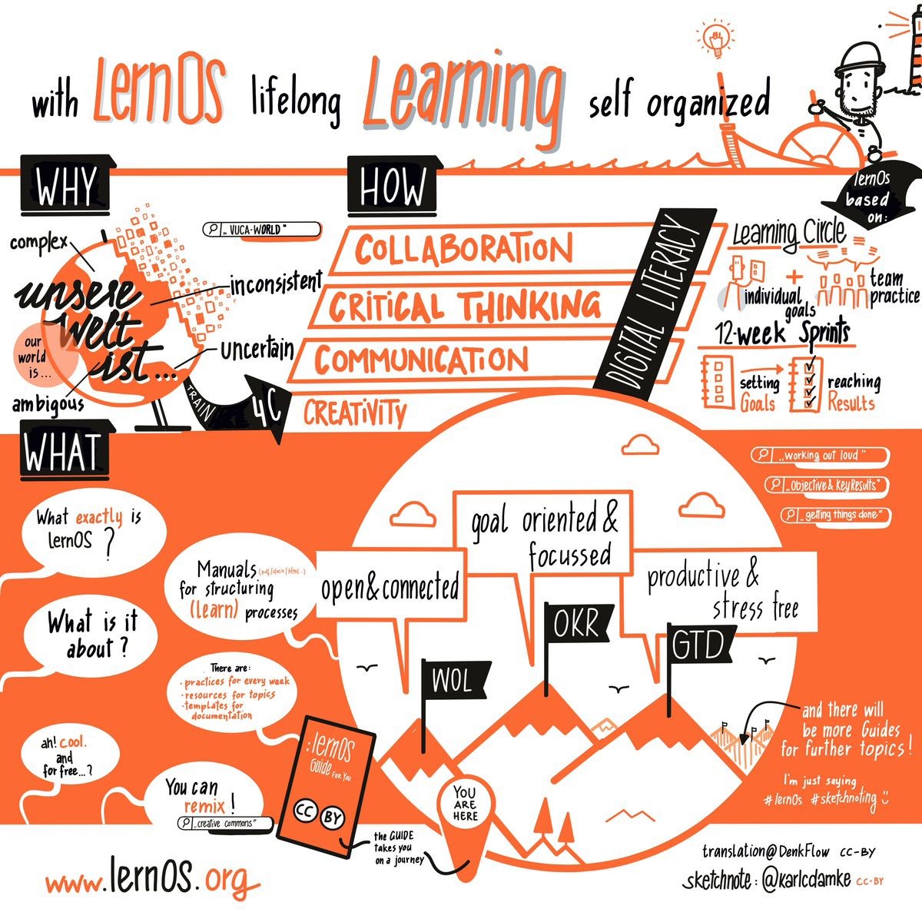

lernOS in an Nutshell

If you want to know more, you can read everything about lernOS at Cogneon, download the guide there or listen to [this podcast](https://colearn.de/clp066-aufzeichnung-cl-sprint-12-4-2019-die-kunst-des-selbstgesteuerten-lebenslangen-lernens/) with lernOS mastermind Simon Dückert. In the lernOS Sketchnote guide we will refer to specific contents of the lernOS guide or further resources. But don’t stress yourself and concentrate on the contents and methods that are directly crucial for you—so you still have something left for the next sprints ;)

**Why do I need a Learning Path for Sketchnoting?**

In the current [VUCA](https://en.wikipedia.org/wiki/Volatility,_uncertainty,_complexity_and_ambiguity)-world, sketchnotes can be a super useful tool that helps you structure and deeply understand information. But they can also help you learn new things, or support you and your team to get a common picture.

As with everything, the same applies to sketching: Practice makes perfect! Motivation, constructive feedback and access to useful resources are the base for practice that is fun. And you’ll stick with it only if it’s fun.

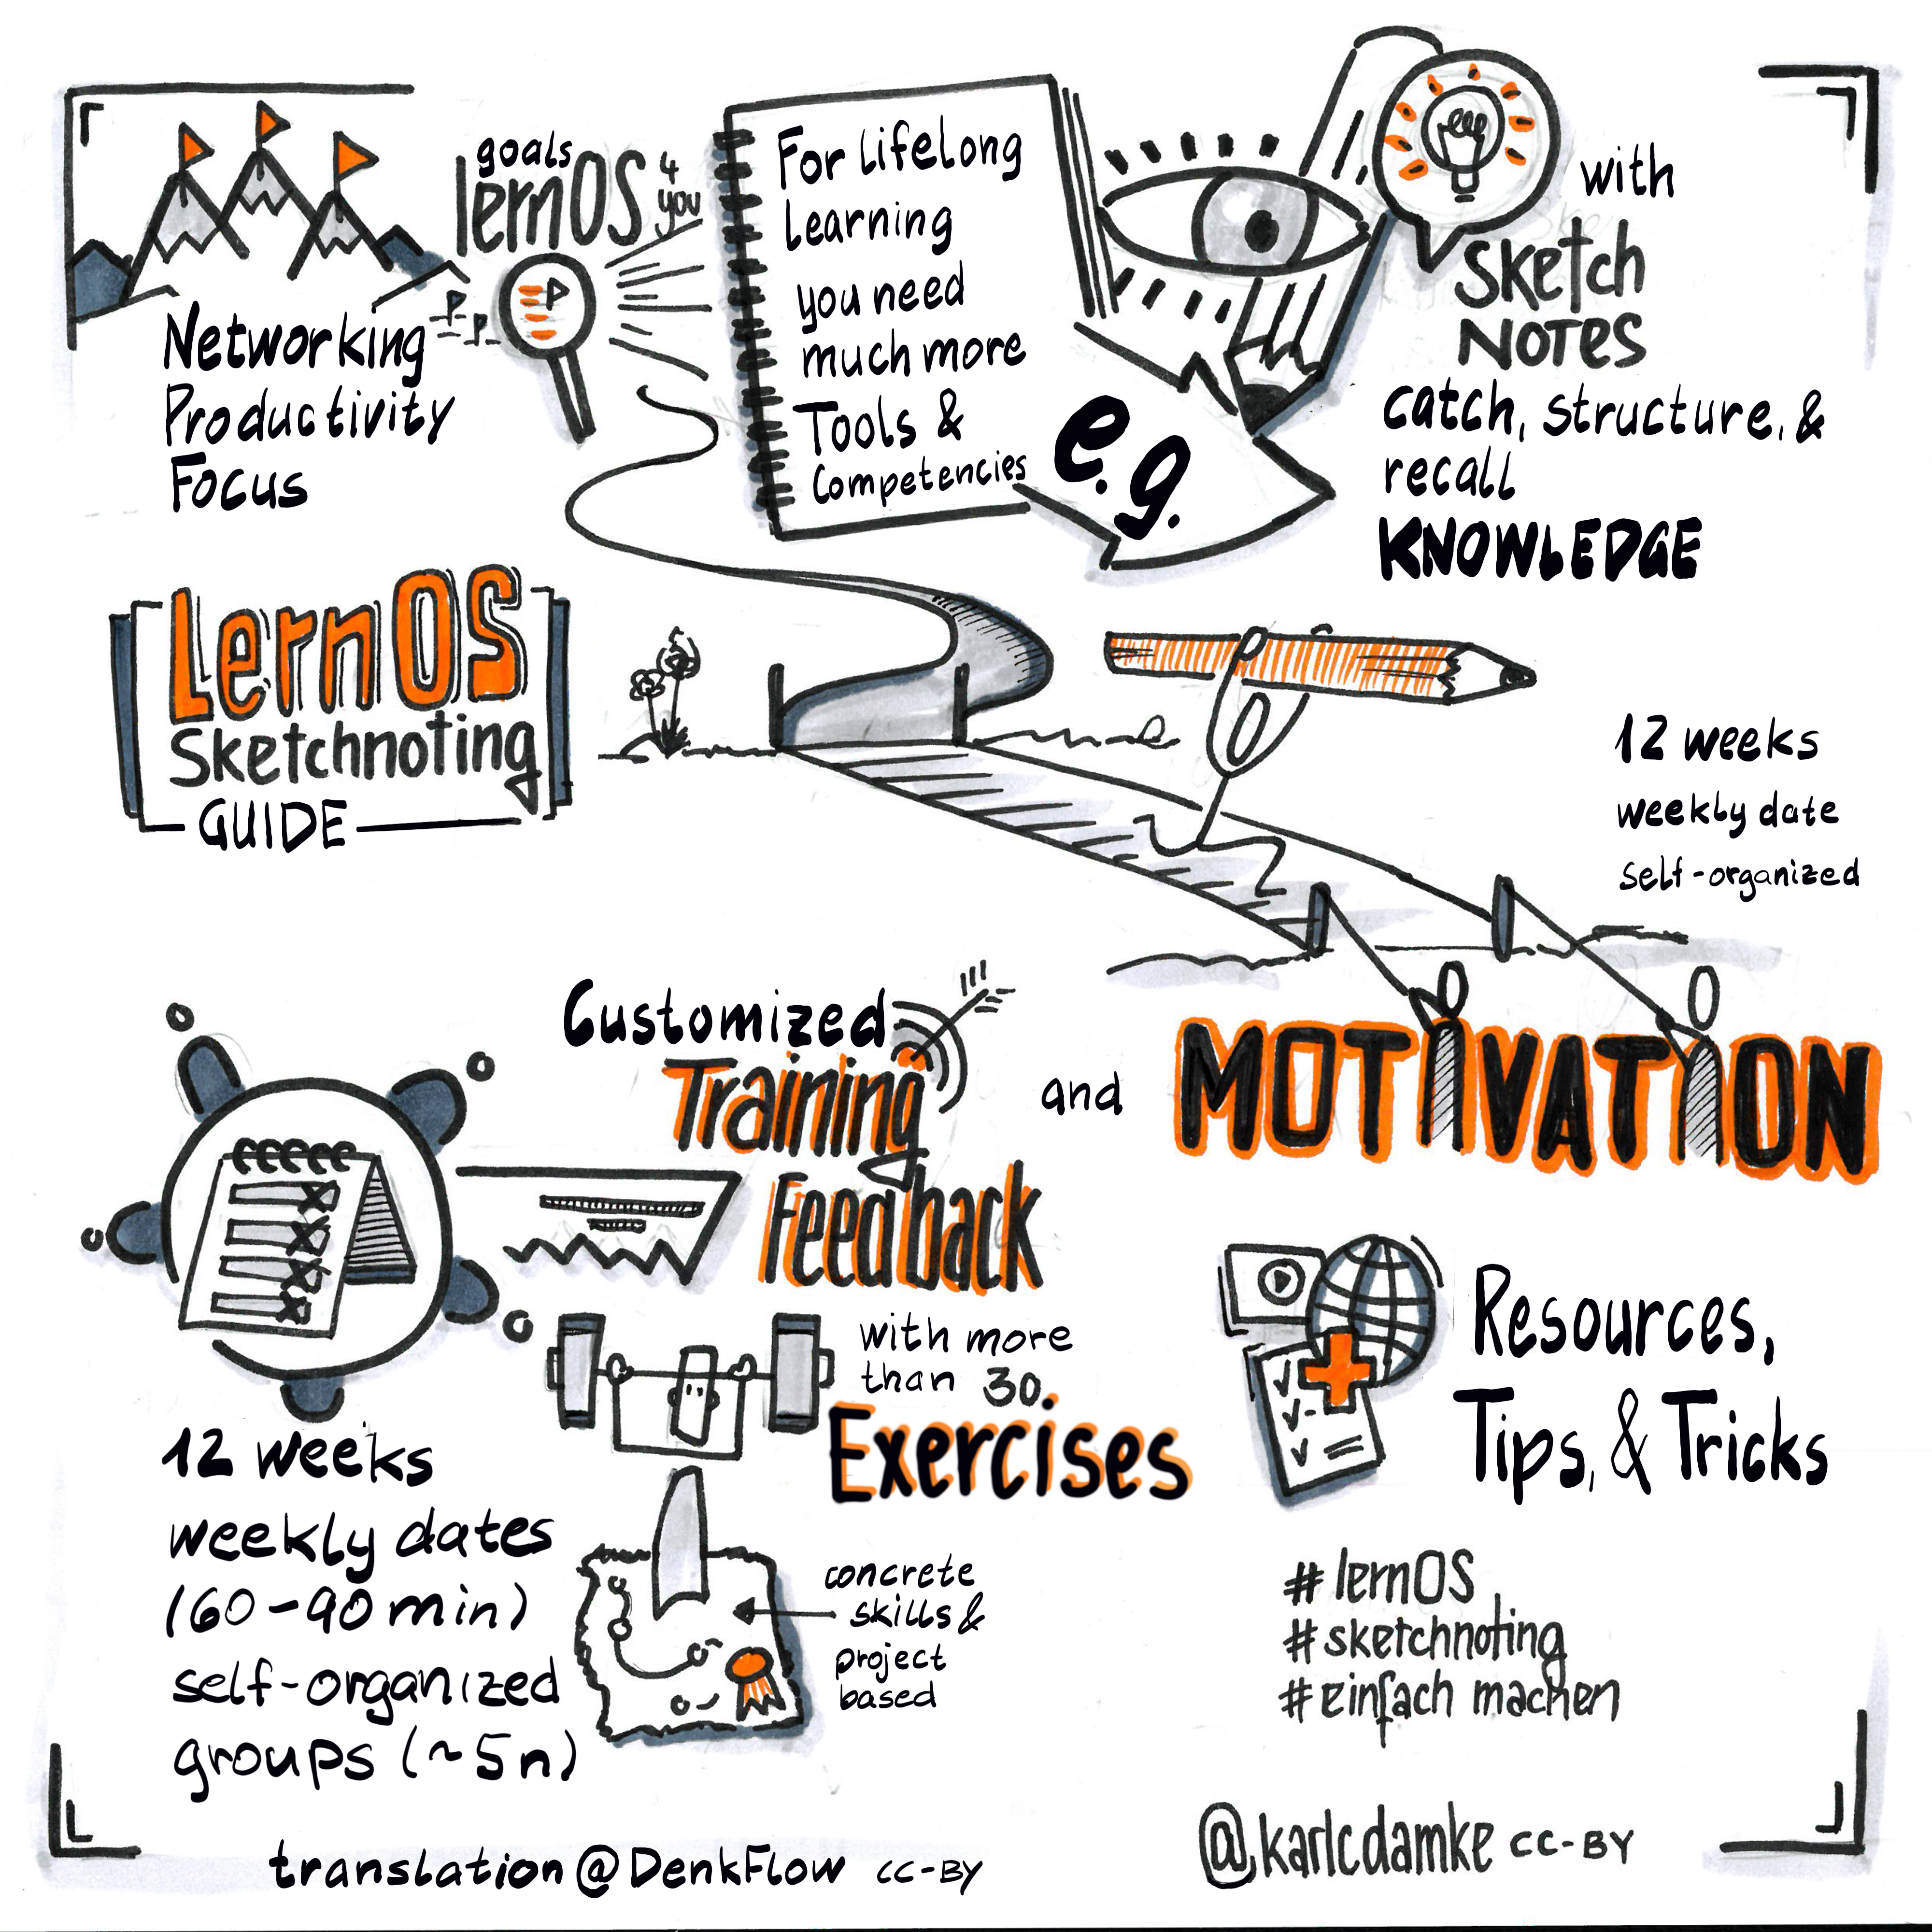

lernos_sketchnnoting_in_a_nutshell

For this purpose, we have developed the lernOS sketchnote learning path. It contains:

1. An introduction to sketching & knowledge about materials and basic
2. 23 katas (exercises) for the essential parts of sketchnotes
3. Resources for further learning, networking and inspiration

The learning path works for all “levels”, whether you have been sketching for 5 minutes or 5 years. If you are at the very beginning, the following chapter will surely help you get started.

## What are Sketchnotes?

*“Sketchnotes are visual notes that consist of a mixture of handwriting, drawings, hand-drawn typography, shapes and graphic elements such as arrows, boxes & lines.”* *- Mike Rohde, author of* [*The Sketchnote Handbook (Peachpit Press, 2013)*](http://rohdesign.com/) *and coiner of the term sketchnote.

*“Sketchnotes is scribbling while you take notes”* *- Kevin Thorn,* [*Nuggethead*](http://nuggethead.net/2013/01/what-are-sketch-notes/)

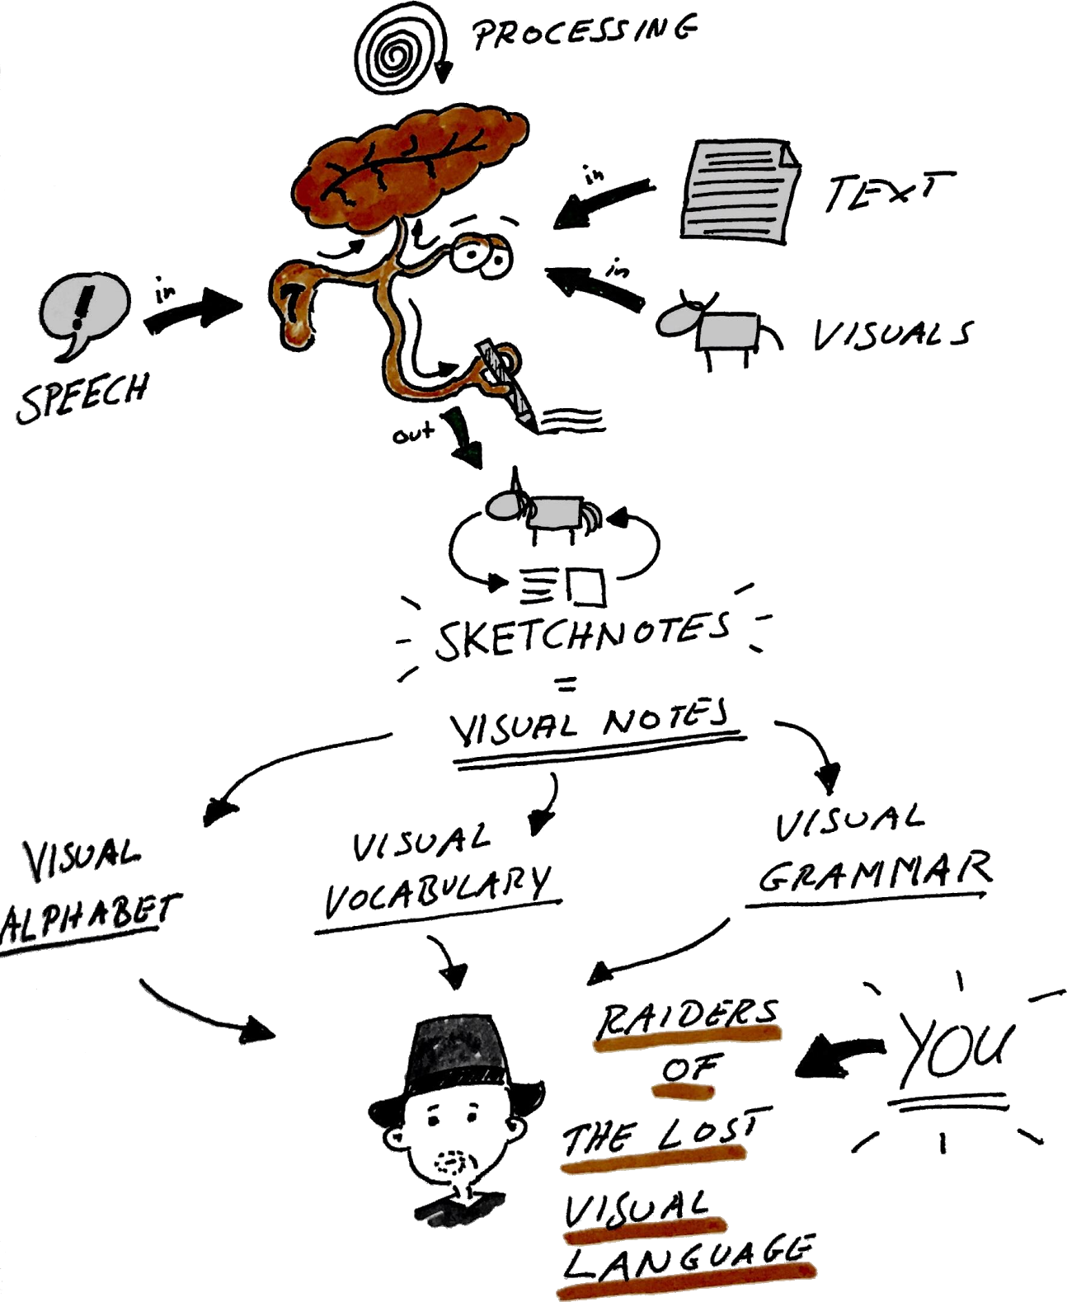

What are Sketchnotes - by @BartschatLars, CC BY 4.0

Who didn’t paint, draw and especially scribble on all surfaces as a child? Doodling is a super-easy way to understand and share information. In her TED Talk “[Doodlers, unite!](https://www.ted.com/talks/sunni_brown?share=11cb8401a9&language=en#t-29444)”. In her book, “The Doodle Revolution,” Sunni shows how strongly sketching information motivates innovation and creative thinking, by making it concise and easy to understand.

Historically, we humans are visual beings. We have been using images for more than [20,000 years](https://journal.lib.uoguelph.ca/index.php/perj/article/view/3137), and the oldest cave paintings are even older. As of publication, the oldest are in the Maltravieso cave, Cáceres, Spain, dating back more than [64,000 years](https://en.wikipedia.org/wiki/Cave_painting).

From a scientific point of view, the “[Dual Encoding Theory](https://en.wikipedia.org/wiki/Dual-coding_theory)” supports sketches. This theory describes that information that is encoded and stored twice—in this case text and image —is more firmly anchored. It can be recalled more quickly and accurately than “simple” text notes. The use of pen and paper, or digital stylus and tablet, therefore has immense advantages over typing on a laptop in a lecture or meeting. (see the article by [Oppenheimer und Mueller](https://journals.sagepub.com/doi/10.1177/0956797614524581)) DThe sketchnoter’s deep understanding of concepts and ideas is much faster and easier than that of the “co-writers,” who put everything down on paper word-by-word or transcribe it to their notebook.

Maybe that’s because scribbling and sketching is a constructive process in the brain. We have to assemble the different elements like LEGO bricks and integrate and organize our knowledge to avoid chaos on paper. As Hazel Messenger writes in her article “[Drawing Out Ideas](https://web.a.ebscohost.com/abstract?direct=true&profile=ehost&scope=site&authtype=crawler&jrnl=18359442&AN=120666112&h=j66cPhqDECmzFTzdusRYarMmVfAAlKKDXnRef90BzvF9NuVMYq8%2fTh%2fERMpVyXIr8FJNnm8i0T0Vhw%2fkJW0hZQ%3d%3d&crl=f&resultNs=AdminWebAuth&resultLocal=ErrCrlNotAuth&crlhashurl=login.aspx%3fdirect%3dtrue%26profile%3dehost%26scope%3dsite%26authtype%3dcrawler%26jrnl%3d18359442%26AN%3d120666112)” the combination of sensing, feeling, thinking and doing contributes simultaneously to sensemaking, i.e., it is constructed from all these building blocks.

In summary: images, especially in combination with text, are superior to plain text for sensemaking, recall, and attention. In literature, the term [Picture Superiority Effect](https://psycnet.apa.org/record/2011-13423-001) is used to explain this phenomenon.

If all this is too complex and text-heavy for you, we have created a sketchnote for you:

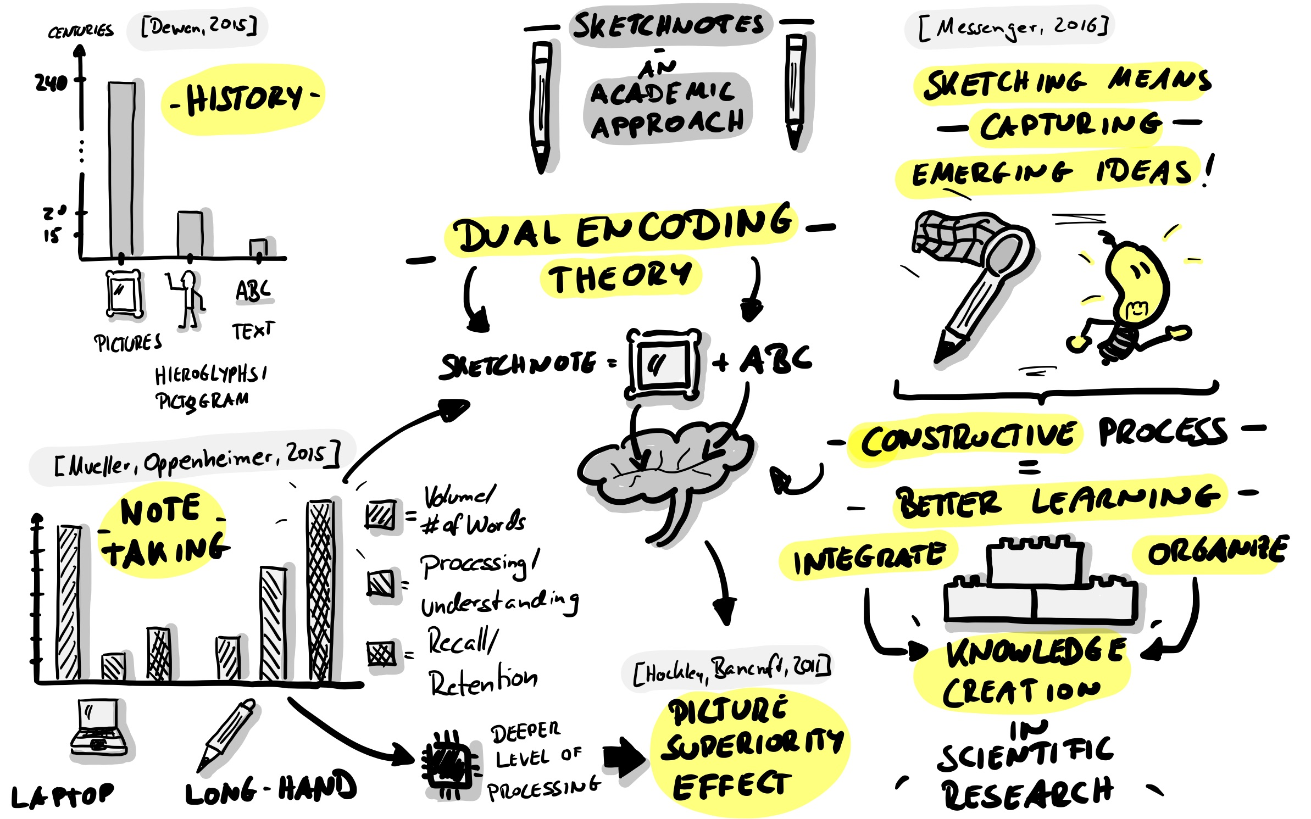

Sketchnotes - An Academic Approach by @BartschatLars, CC BY 4.0

## What can I do with Sketchnotes?

You can sketchnote almost anything. Here are just a few examples:

* Recipes
* Processes
* Organizations
* Stories
* Marketing plans
* Business models
* University lectures
* Math lessons
* Church sermons
* Relationship maps
* Stage plays
* Book contents

So you can use sketchnotes too:

* Deeply understand content
* Focus yourself
* Sketch solutions to problems
* Find ideas
* Tell stories
* Accumulate wealth (maybe…)
* Muck around
* Improve cooperation
* Share knowledge with other people!
* Create participation and understanding
* Dismantle barriers
* Amplify voices and ideas

## What do I need for sketchnoting?

You might think, “that all sounds very nice, but what do I need to start sketching? Isn’t it all very complicated?” Good news—it’s not. The only thing you actually need is a pen and some paper you can sketch on. It could be a pad, a notebook, a napkin or even a coaster. Of course, you can also digitally create sketchnotes on a tablet. We’ll discuss each in turn below.

### Sketchnotes with pen and paper

Sketchnotes with pen and paper are the “original” way of making visual notes. This “analog” approach has many advantages. Some of them are very subjective. It is best to form your own opinion:

* Paper doesn’t have a battery that gets exhausted just when you want to take sketchnotes.Pen and paper do not continuously distract you with notifications.
* If your notebook gets wet, you can dry it, and it will probably still be readable afterward. Throw your tablet in the bathtub, though…
* Writing and drawing on paper just feels “right”.
* Pen and paper have a very intuitive user interface.
* In a digital age, you are almost a rebel with pen and paper.
* You can put a sketchnote on paper in someone’s hand, and you can touch it and experience it haptically.
* A sheet of paper has limits. Through this limitation, you learn to focus on the essentials, the core messages over time!
* Pen and paper is the cheapest way to sketch!

There are a few things that pen and paper are actually not so good at:

* To share an analog sketchnote online, you first have to scan or photograph it (the following apps are handy for this purpose: CamScanner, Office Lens, or Adobe Scan.)
* Copy and Paste or Cut and Paste are possible with paper, but they are very time-consuming!
* Corrections are not that easy. Potentially they “disturb” the overall picture.
* Enlarging and reducing elements is also not really possible …
* A sheet has limits - “Full is full”, you can’t extend analog sketchnotes at will. (Except with plenty of tape…)

Even if many websites tell you otherwise, you don’t need any special paper or especially expensive notebooks, nor do you need costly pens. To get started, just take a sheet of paper from the printer and the first available pen on your desk.

#### Paper and pen recommendations

You can find an extensive list on the [Sketchnote Hangouts](https://sketchnotehangout.com/resources/) website.

We choose not to list brands and products here. We think sketchnotes don’t need expensive pens and fancy notebooks. The simplest schwag pens and the back of a failed print are fine.

A “too beautiful” sketchbook is sometimes just that, too beautiful. You don’t dare to start “ruining” beauty because you’re afraid of it. So: [KISS - Keep it simple, stupid!](https://en.wikipedia.org/wiki/KISS_principle)

### Digital Sketchnotes

Meanwhile, you can also do kick-ass digital sketching. For this, a tablet computer is a typical recommendation, as most smartphones are still too small, although a Samsung Galaxy Note could be enough as Opels Art shows [here](https://www.youtube.com/watch?v=Lai-GBlRq9Y). Most tablets are a little more comfortable, such as the Apple iPad (Pro), the Samsung Galaxy Tab or the Microsoft Surface series.

Digital sketching has immense advantages:

* Some apps let you quickly move, zoom in and out, cut and copy elements.
* Online sharing is virtually built-in.
* Your sketchnotes are stored on a file system and may even be searchable.
* Some apps offer you unlimited space to sketch (e.g. the “unlimited canvas” in the Concepts app), if you think of any critical points later on, you can add them at any time.

Like pen and paper, sketchnoting on the tablet has a few disadvantages:

* With a dead battery, you’re back in the dark ages.
* Don’t drop the tablet. Neither in the bathtub nor on the floor!
* A tablet with a stylus (pen) is not cheap.
* Writing and drawing on glass feels strange, at least in the beginning. #ProTip: A matte screen protector creates a rougher surface. Many digi-sketchnoters like this slightly paper-like writing feeling.
* Your first sketchnotes with any app will be slow as you get used to its interface and feature set. You’ll need to build expertise to get fast.
* The operating system notifications can be very distracting as you sketchnote.
* Unlimited drawing space can be overwhelming, and you want to include every little dot in your sketch note. Sometimes less is just more.

Apps that can be used for sketchnoting:

* [ProCreate](https://procreate.art/) - with costs, for iOS (Doug Neill presents[ProCreate as sketchnote tool](https://www.youtube.com/watch?v=jhd8WQ9cBww) in a video)
* [Paper by WeTransfer](https://paper.bywetransfer.com/) (formerly by 53) - Basic version free, subscription model, for iOS
* [Concepts](https://concepts.app/) - Basic version free, for iOS, Android, Windows
* [Tayasui Sketches](https://tayasui.com/sketches/) - Basic version free, for iOS, Android
* [GoodNotes 5](https://www.goodnotes.com/) - with costs, for iOS,

You can find a comparison of different apps at [Timo](https://sketchnoting.net/sketchnotes-apps/) and on [Pixpa](https://www.pixpa.com/blog/drawing-apps).

## Sketchnote Elements

No matter what the theme is, you’ll always use the same elements for your sketches. If you want to train in the fundamentals, or need some inspiration and variety, we recommend “Sketch it – The Card Game” by Wibke Tiedmann and Stefanie Maurer. You can download it [here](https://sketchnotegame.wordpress.com/download-kartenspiel/)and use it under the Creative Commons Attribution-ShareAlike 4.0 International license. (CC BY SA 4.0). Following examples of Sketchnote elements originate from this game.

*„*[*Sketch it – Das Kartenspiel*](https://sketchnotegame.wordpress.com/download-kartenspiel/)*„ by*[*Wibke Tiedmann & Stefanie Maurer*](https://sketchnotegame.wordpress.com/ueber/)*, Lizenz:*[*CC BY-SA 4.0*](https://creativecommons.org/licenses/by-sa/4.0/deed.de).

### Container

A container structures a sketchnote by providing a frame for other elements.

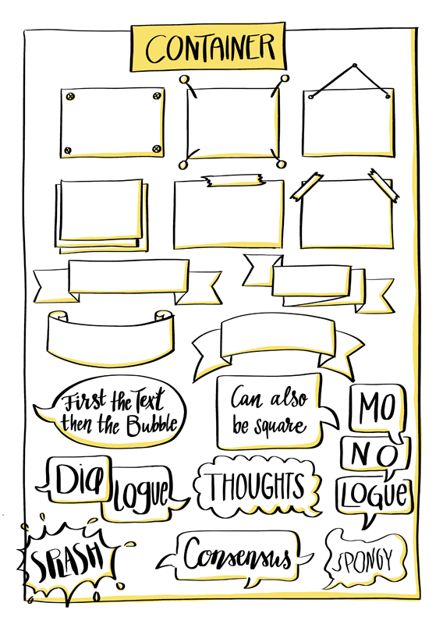

### Separator

The separator ensures that the elements of a sketchnote are distinct from each other, thus creating order and clarity.

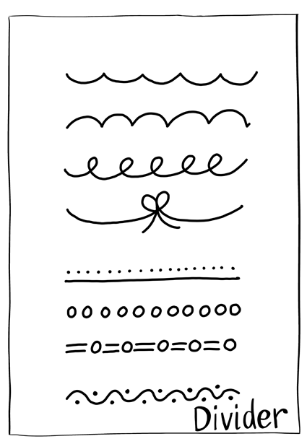

### Text

Your sketchnote consists of text and graphic elements, and the text elements can also take on different shapes and colors.

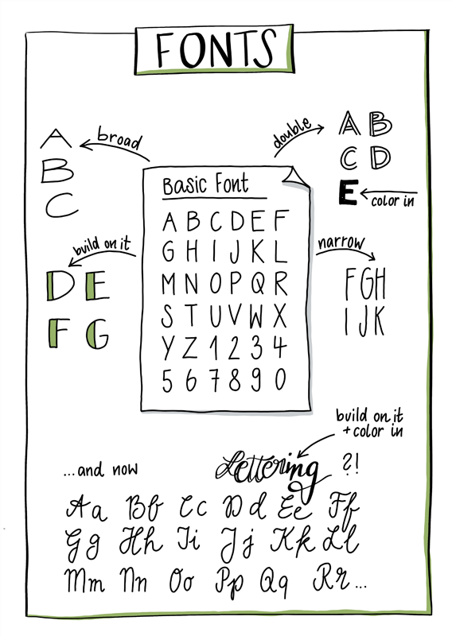

### Symbols and Icons

You can use symbols and icons in different ways when sketching. For example, you can create an personalized icon set for recurring concepts. A classic example is a glowing light bulb for an idea, or an exclamation mark for something important.

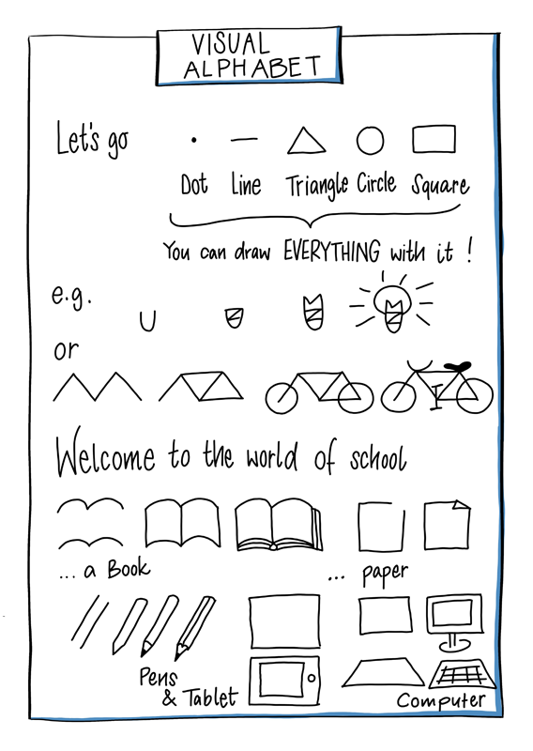

### Connectors and arrows

Connectors and arrows are strong structural elements in sketching. They create the flow that the eye of the observer follows. They show which part follows which, for example, in a temporal or logical sequence. Connectors and arrows hold your sketchnote together. They are the natural counterpart of the separator.

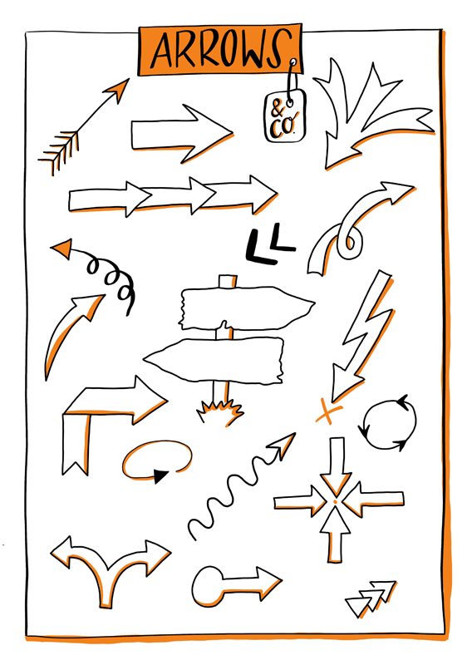

### Characters

The characters are the actors in your sketchnotes. They can be used to depict the actions and emotions of individuals but also of teams or groups in different situations. Adding faces or facial expressions can be helpful to show emotions. You can express a lot of feelings and emotions through the posture of characters as well. So whether you give the figures a face or not depends almost entirely on your style.

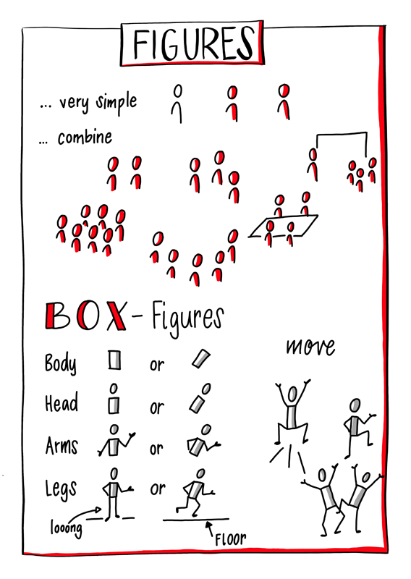

### Diagrams

Diagrams are well-suited to visualizing data in a sketchnote. With a bit of practice, you can create simple but powerful charts from elements like bars, lines and circles. An awe-inspiring example of analog data visualization is the project “[Dear Data](http://www.dear-data.com/theproject)” by Giorgia Lupi and Stefanie Posavec, who sent each other postcards with hand-drawn visualizations for over a year.

## Sketchnote Workflows

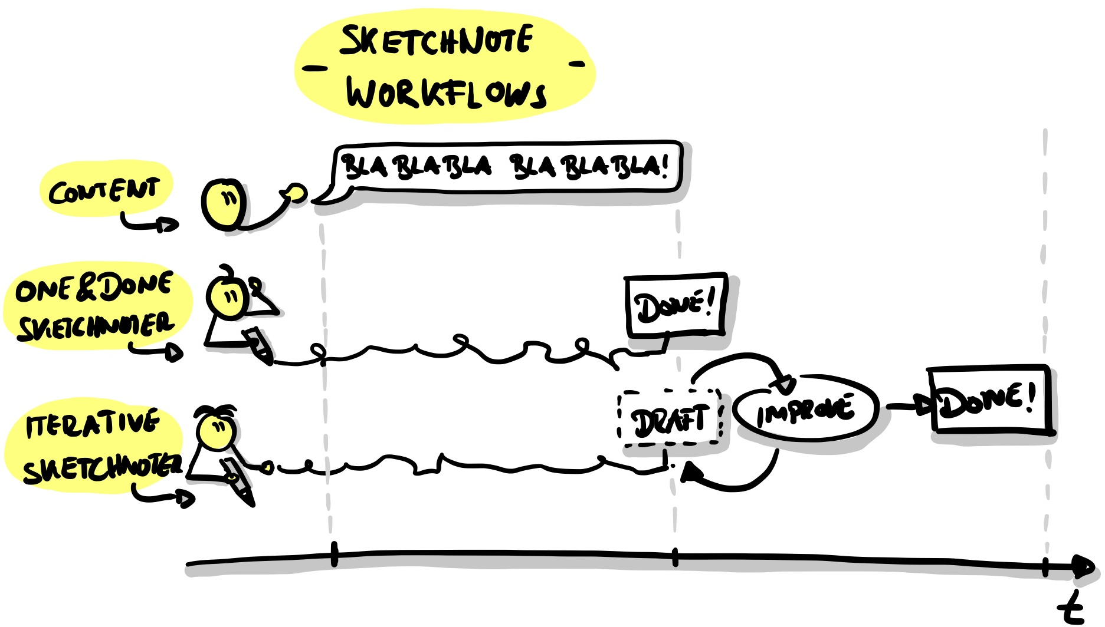

Sketchnotes Workflows by @BartschatLars, CC BY 4.0

### “One and done” vs. iterative Sketchnoting

“One and done” sketchnoters create sketchnotes during a conference talk or meeting. “One and done” means that you’re done with the sketchnote as soon as the event is over. You might have to correct or add a few small details at the end, but “one and done” is “live”.

Contrast this to iterative sketching, in which you work in several, but usually two, steps. During an event, an interative sketcnoter creates a rough draft version, which is then revised and finalized after the event. This allows you to work in more detail and accuracy than with the “one and done” approach, but can be tempting for the perfectionist to spend way much more time completing the final product.

Mauro Toselli, known as [@xLontrax](https://twitter.com/xlontrax), describes an even more in-depth process in his book “[The xLontrax Theory of the Sketchnote](https://www.maurotoselli.com/the-xlontrax-theory-of-sketchnote.html)”:

* Mauro collects the material and creates the first sketchnote.
* Afterward, he leaves it to “mature” until the next session.
* He then examines the sketchnote in detail…
* …before removing anything superfluous.

Mauro defines the “Eraser Critical Point” for this. He describes it as “the number of elements you must remove from your sketchnote to compromise its meaning.” So his approach ensures that a sketchnote has just the right number of elements to convey the desired content. In his experience, with skilled “one and done” sketch artists, this complex process is automated during the sketching process.

Which workflow is the right one? That depends on many things:

* What type of sketchnoter are you: One-and-done or iterative?
* What fits the current situation?
* How much time do you have?
* How do you want to use your sketchnote afterward?

There is no right or wrong, sketchnote as you need it!

Mauro has made a summary, especially for this learning path:

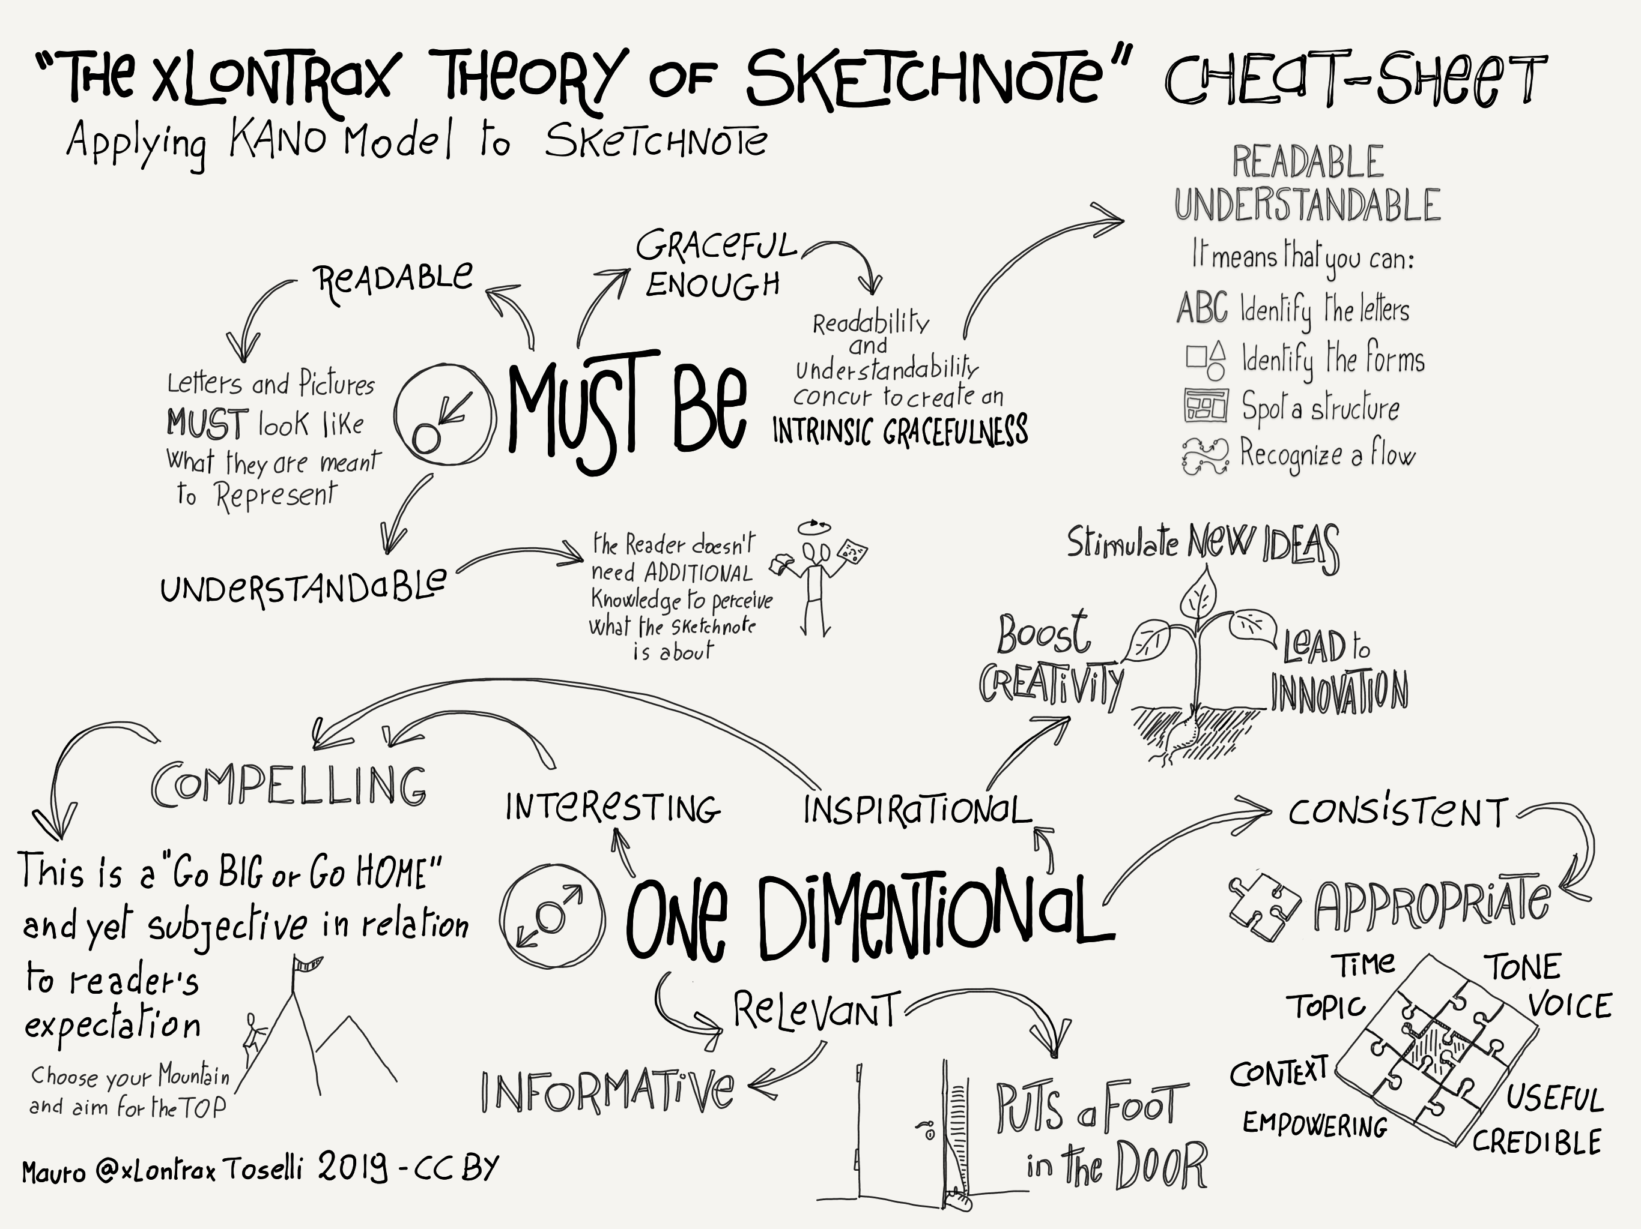

The xLontrax theory of sketchnote by Mauro @xLontrax Toselli CC-BY

# The Sketchnote Learning Path

This course recommends that you spend 12 weeks working on a topic. That could be both a lot of time and also very little time. The katas (exercises) in this guide are designed to help you get the most out of yourself and your circle. They are designed to be suitable for both beginners and advanced students. Before you start the sprint, take some time to look at the structure and the individual katas. Sometimes there are several katas in one week.hoose one or do both, depending on your mood. There is no kata police: simply exchange katas or modify them to fit your goals better. You can also have a look at the other [LernOS guides](https://github.com/cogneon/): Which katas do they suggest? Are they better suited for you?

**How is this learning path structured?**

Let’s look at it from two perspectives. First, we look at when you are part of a learning circle over the twelve weeks. Then we look at the katas regarding the structure.

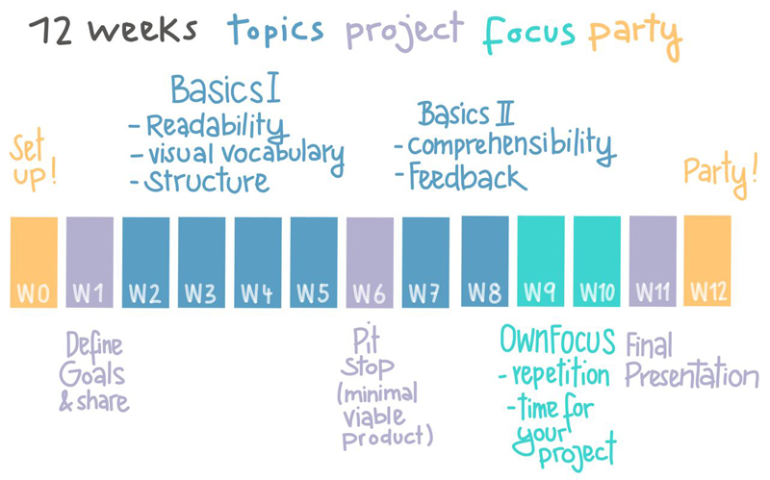

Sketchnote Learning Path by Karl Damke CC-BY

Sketchnoting is different for everyone and will always be different for you too, depending on the situation. Nevertheless, there are essential qualities that characterize a sketchnote that bears returning to even after years, and which can be understood by your colleagues. Toselli, mentioned above, has been developing a working list of these qualities for years. We took his list and built the Katas on them.

## How do I find more Circle Members?

A group of students studying the same thing is called a learning circle in this text. If you’re eager to start, but don’t know where to find other circle members, what can you do?

If you are in social networks like Facebook, Instagram or Twitter, post there and ask for interested people. If you use the hashtags #lernOS and #sketchnoting in your post, people following those threads will see it as well. You can also tag the authors of the guide, so your post can be seen and forwarded more easily.

## Circle Organizer Checklist

**#ProTipp:** in many cases, the weekly meeting does not have enough time for doing the exercises. Therefore we use the [flipped classroom method](https://en.wikipedia.org/wiki/Flipped_classroom). For each weekly, there is a kata, which each circle member prepares as “homework,” so you have more time to discuss the results in the weekly. This is accompanied by guiding questions, which you are welcome to add.here are also shorter katas that you do together during the weekly.

You should choose your focus for the sprint: - What do you want to learn or deepen? - In which skills are you already confident? - What is challenging? - What’s up right now? - What’s next? - What would be a better focus for a different sprint? - Are you “one-and-done” but find it frustrating? - Or would you rather aim at “practice makes progress (and fun)” (building on Brandy Agerbeck’s awesome phrase.)

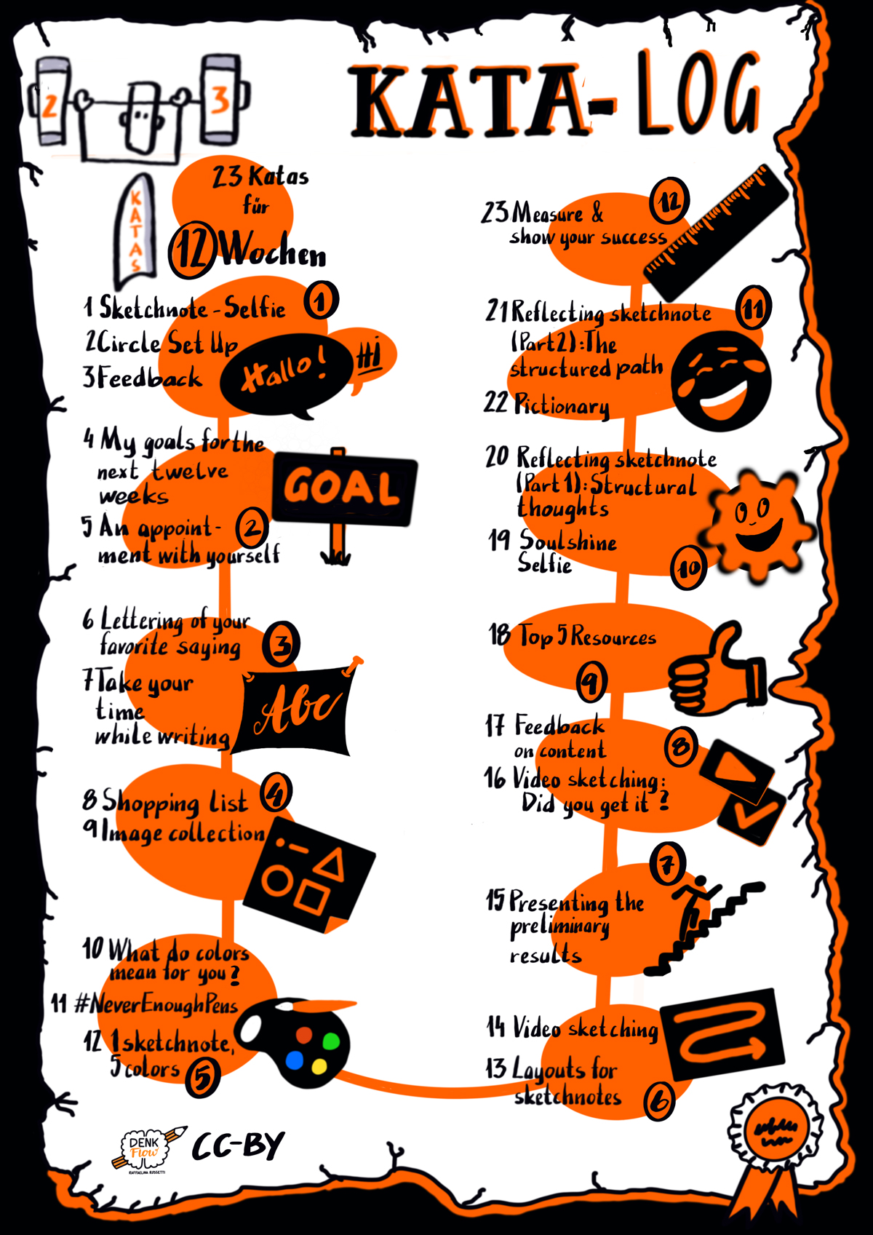

Kata-Log by @DenkFlowRR CC-BY

The katas listed here are suggestions. Think of them not as prescriptive, but as inspirational.. If there are different katas to choose from, which one fits your focus best? Or do you want to do them all? If you have your own ideas for katas (or variations) that suit your main emphasis, even better, use them! And if you share them with us or add them to the learning path yourself, you will help all the others who follow the learning path after you! (… and of course, earn some tasty karma!)

On the following pages, you will find a short version of the sprint schedule. The explanations for the individual katas and warm-ups follow on the pages after that.



## Week 0: Planning the sprint and making arrangements

Before we start, invest some time to get to know each other and discuss the conditions for your sprint.

**As preparation**

* ☐ Kata 1: Sketchnote-Selfie

**In the weekly**

* ☐ Check-in (2 minutes per member)
* ☐ Warm-Up: Squiggle birds (5 minutes)

Introduction: Who are you? Introduce yourself. Here, of course, you should use your sketchnote-selfie as a guide. (5 minutes per member)

**Key questions**:

* Do you prefer to work digitally or analog?
* Do you use sketchnotes more privately or professionally?
* How long have you been doing sketchnotes?
* What are your favorite materials (paper, pens, programs)?
* ☐ Kata 2: Circle setup (20 minutes)
* ☐ Kata 3: Feedback (10 minutes)
* ☐ Check-out (1 minute per member)



## Week 1: Setting goals

This week you choose your goal for the sprint.

**As preparation**

* ☐ Kata 4: My goal for the next 12 weeks
* ☐ Kata 5: An appointment with yourself

**In the weekly**

* ☐ Check-in (2 minutes per member)
* ☐ Warm-up: Goals (5 minutes)

How do you visualize goals? Draw icons and compare them. How do you visualize that the goals have been achieved?

**Share: Your goals in the sprint (10 minutes per member)**

* ☐ Share your goals from Kata 4.

**Key questions**:

* Why are you doing this?
* What inspires you?
* What does it mean to you to have achieved a goal?
* How did you make your goals quantitatively measurable according to OKR?
* How do you celebrate when you have reached your goal?

**Share: An appointment with yourself (5 minutes)**

* ☐ Have you all set up an appointment with yourselves in the calendar? What helped you?
* ☐ Check-out (1 minute per member)



## Week 2: Writing & Readability

Week 2 is about the written word: How does it best support the message of your sketchnote, and how do you get there?

**As preparation**

* ☐ Kata 6: Letter your favourite saying
* ☐ Kata 7: Take your time while writing

**In the weekly**

* ☐ Check-in (2 minutes per member)
* ☐ Warm-up: Very big and very small.
* ☐ Feedback, share and tips on the katas (40 minutes)

**Key questions**:

* How do you use different fonts in your sketches?
* Which of your fonts do you use for what?
* Which of your fonts do you like best? Which ones don’t you like?
* Do you want to learn a new font, and what do you need it for?
* How do pens and writing relate to each other? What is the best pen thickness for your drawing and writing? How do you hierarchize with font size, fonts and pen thickness?
* ☐ Show each other your examples that you find particularly successful.
* ☐ Check-out (1 minute per member)



## Week 3: Visual Vocabulary

Each language consists of individual elements: Develop the visual elements that best suit your visual language and find your style.

This guide brings together many resources (books, videos, social media accounts). You can also find inspiration there and use these resources as a source of inspiration.

You can use the current sprint as an opportunity to start working on your visual vocabulary or to collect visual vocabulary on a specific topic. Maybe this will be your project for this sprint.

**As preparation**

* ☐ Kata 8: Shopping list
* ☐ Kata 9: Icon collection

**In the weekly**

* ☐ Check-in (2 minutes per member)
* ☐ Warm-up: Icons
* ☐ Averyone brings a term with them they find exciting or challenging to visualize. All words are sketched for 30 seconds each and then compared. (5 minutes)
* ☐ Share your experiences with the kata(s) (40 minutes)

**Key questions**:

* How good is your visual vocabulary?
* How do you collect/document your icons?
* What methods do you use to keep them within reach?
* Do you want to continue collecting icons, and how do you want to share them?
* Which icons are your top 5 icons that you use again and again in sketches?
* How satisfied are you with them?
* Can you improve something about them?
* Sketch the icon you want to improve and ask the others.
* ☐ Check-out (1 minute per member)



## Week 4: Structure through pens and color

This week you will discover the world of colors and line widths and how you can use them to accentuate your sketchnotes.

**As preparation**

* ☐ Kata 10: What do colors mean to you?
* ☐ Kata 11: #everenoughpens

**In the weekly**

* ☐ Check-in (2 minutes per member)
* ☐ Warm-up: Fewer details please (5 minutes)
* ☐ Kata 12: 1 Sketchnote 5 colors (20 minutes)

Prepare the kata and finish it together

* ☐ Share your experiences with the katas (25 minutes)

**Key questions**:

* Which colors suit your topics?
* Do you change the colors depending on the topics?
* How do you manage to create structure even if you only have a few pens?
* ☐ Check-out (1 minute per member)



## Week 5: Structure through layout

Week 5 is all about order: Sort and group all the elements used so far and combine them into a coherent layout.

**As preparation**

* ☐ Kata 13: Layouts for sketchnotes

**In the weekly**

* ☐ Check-in (2 minutes per member)
* ☐ Warm-up: Container (5 minutes)

Draw various containers and discuss what they are suitable for. (For example, a cloud stands for an idea rather than a result/decision).

* ☐ Kata 14: Video sketching (40 min)
* ☐ Check-out (1 minute per member)



## Week 6: Your intermediate score

Pit stop: Reflect on what you have achieved, present it to your Circle Members and give feedback to each other. Get ready for the second half of the circle.

**As preparation**

* ☐ Kata 15: Prepare for your presentation in the Weekly.

**In the weekly**

* ☐ Check-in (2 minutes per member)
* ☐ Warm-up: Draw your counterpart (5 minutes)
* ☐ Kata 15: Presenting the intermediate result (10 minutes per member)
* ☐ For Kata 16 next week: Form teams of 2 and arrange to work on the kata.
* ☐ Check-out (1 minute per member)



## Week 7: Comprehensibility

Do you understand me? This week you test whether your sketchnotes convey the statements you intended.

**As preparation**

* ☐ Kata 16: video sketching: Did you get it?

**In the weekly**

* ☐ Check in: (2 Minuten pro Member)
* ☐ Warm-up: Draw Toast (5 minutes)
* [ ]Compare your experiences with the kata

**Key questions**:

* What expectations did you have regarding the comprehensibility of your sketchnote?
* Were these fulfilled?
* How was the feedback regarding readability, layout, choice of words?
* What worked particularly well for you?
* What was particularly challenging for you? (e.g. speaking rate in the video, filtering essential things, …)
* What have you learned for your next sketchnotes, what do you want to keep, and what do you want to do differently?
* ☐ Check-out (1 minute per member)



## Week 8: Sharing for Feedback

After we gave each other feedback in week 7, you are now ready to go public: Get active feedback on the content of your sketches from people outside the circle.

**As preparation**

* ☐ Kata 17: Feedback on content

**In the weekly**

* ☐ Check-in (2 minutes per member)
* ☐ Warm-Up: schedule (week 8)
* ☐ Compare your experiences with Kata 16 (20 Minuten)

**Key questions**:

* Where and how did you split your sketchnote?
* How comfortable/uncomfortable was it?
* What kind of feedback did you get?
* How exactly do you ask for feedback?
* ☐ Kata 18 Top 5 Resources (20 minutes)
* ☐ Check-out (1 minute per member)



## Week 9: Deepening your Project

Setting the course for the final sprint: Develop your project further or deepen what you have learned so far—use the feedback for further self improvement.

**As preparation**

Decide what priorities you want to set.

* ☐ If you are working on your project that you would like to complete by week 11, in this sprint take the time to work on it again and get feedback on it.
* ☐ If you don’t have a concrete project/product, then use Kata 19 and [20]/[21] to reflect on the sprint and what you have learned so far.
* ☐ Kata 19: Soulshine-Selfie
* ☐ Kata 20: Reflecting sketchnote (Part 1) “Structural Thoughts”

**In the weekly**

* ☐ Check-in (2 minutes per member)
* ☐ Warm-up: visual communication makes the difference (5 min)
* ☐ Feedback on your projects, exchange ideas about kata Kata 19 & [20] and free repetition
* ☐ Check-out (1 minute per member)



## Week 10: Fun is a must!

Or also: “Embarrass yourself daily” :-) - Try your hand at improvising and the spontaneous presentation of your associations.

**As preparation**

* ☐ Think about terms for Kata 22: Pictionary
* ☐ Kata 21: Reflecting sketchnote (part 2) “The structured path”

**In the weekly**

* ☐ Check-in (2 minutes per member)
* ☐ Warm-up: figures in action (5 minutes)
* ☐ Share your experience with Kata 21
* ☐ Kata 22: Pictionary (25 min)
* ☐ Check-out (1 minute per member)



## Week 11: Final Products and Lessons Learned

One can be proud sometimes: Show your Circle Members what you have achieved and what you have learned (also about yourself).

**As preparation**

* ☐ Kata 23: Measure & Show Your Success

**In the weekly**

* ☐ Check-in (2 minutes per member)
* ☐ Warm Up: Emotions (5 Minuten)
* ☐ Presentations (10 minutes per member)
* ☐ Check-out (1 minute per member)



## Week 12: Reflection and Conclusion

You have set out. But have you already reached your destination? What’s the next step? Have you found your passion? Was this after or before the circle? And when do we actually go out and celebrate?

**As preparation**

* ☐ What’s next? What do you plan to do next?

**In the weekly**

* ☐ Check-in (2 minutes per member)
* ☐ Warm-Up: Special Features (5 minutes)

This week there is no clearly defined program with further exercises. You already presented the results of your work in week 1. Now is the time to finish the sprint together. Talk about the circle and your experiences in the last weeks. What have you learned and what has the learning path done to you. How can you continue after the sprint?

Wow, you did it and finished the sprint! Congratulations! How can it continue? Some circles continue to meet regularly, but in longer intervals (e.g. every 2 or 4 weeks instead of every week). In this way, you can work on specific topics from the learning path in greater depth or katas, and repeat warm-ups. How about a new iteration of the Sketchnote Learning Path with new goals and focus?

I’m sure your circle has its ideas about what you want to work on. You might bring in application ideas from your fields of work or interest and create exercises from them.

Discuss what you want to fill in the weeks after the sprint, because it’s essential to keep up with it to strengthen further the skills and positive habits you have built up during the sprint. Be sure also to discuss how you want to proceed with the shared resources you have (online platforms, sketches from the others, etc.)

* ☐ You’ve done a great job in the last few weeks - you should definitely celebrate that this week.
* ☐ What’s next?
* ☐ Check-out (1 minute per member)

# Kata-Log

## Kata 1: Sketchnote-Selfie

Used in Week 0

To introduce yourself to others in your circle, draw a sketchnote about yourself. Include the following. - The most important facts about yourself - Things you do and don’t like - Two facts about yourself that are not obvious - A handy sketchnote tip. Also, try to answer the question of why you visualize. Feel free to use the guiding questions from week 0, which you could edit in your Sketchnote selfie. When you’re done, share your Sketchnote selfie with the others.

Example of a Sketchnote Selfie:

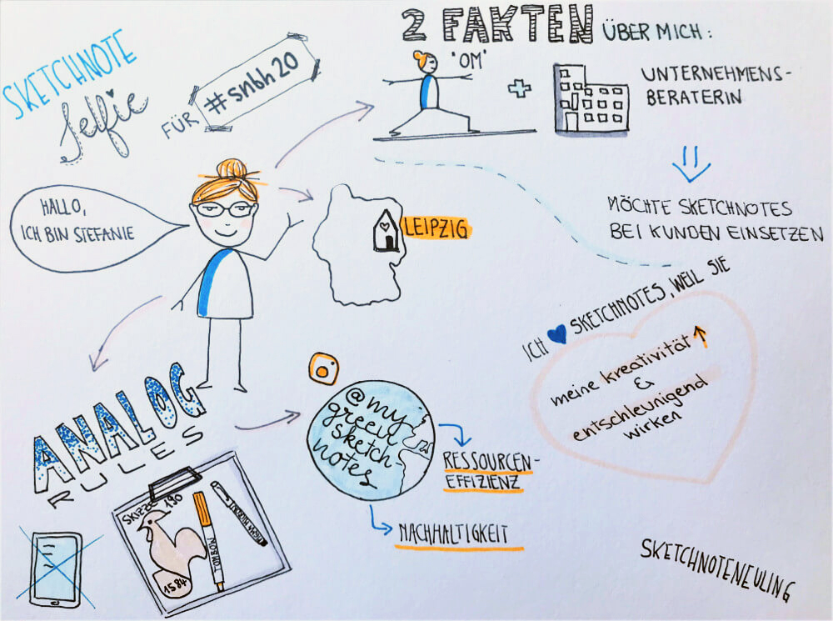

Sketchnote-Selfie by @mygreensketchnotes CC-BY

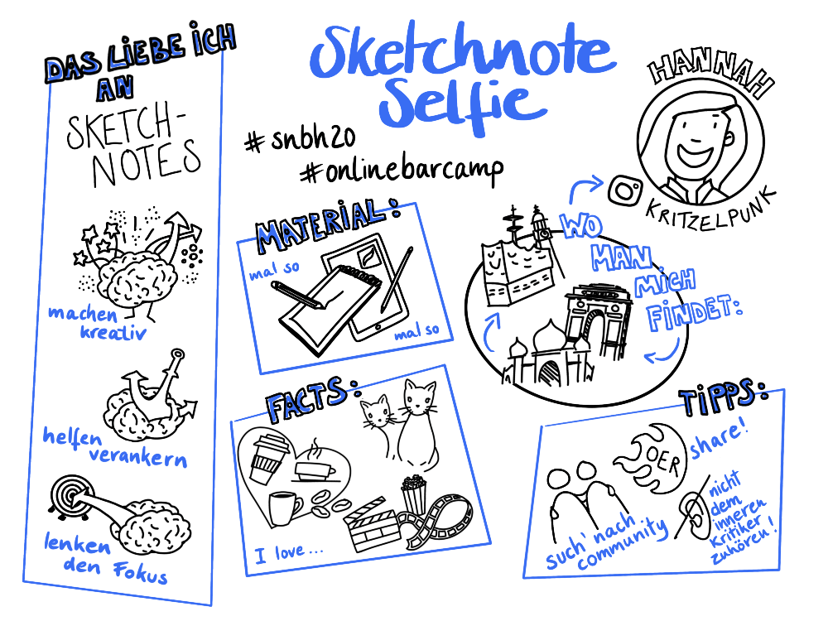

Sketchnote-Selfie by @kritzelpunk CC-BY

If you are still very new to sketching, the kata [“25 Facts About Me”](https://cogneon.github.io/lernos-for-you/en/2-1-8-Kata-8/) might be a good starting point. And to make it easier to visualize the 25 or as many facts as you’d like to have on your selfie, you might find some inspiration in the [Noun Project](https://thenounproject.com/).

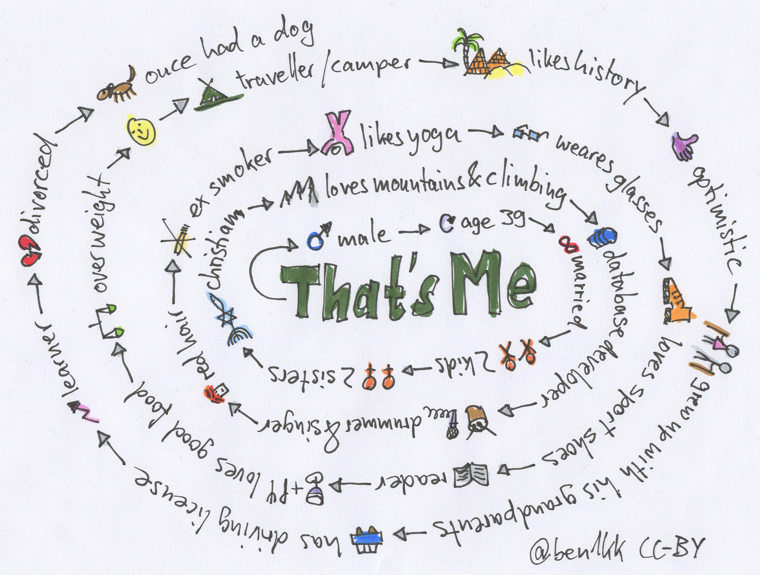

25 Fakten by @ben1kk CC-BY

**Objective:**

* Get to know the other members and introduce yourself with a sketchnote.
* With a Sketchnote Selfie, you show yourself and the others what you already know.

## Kata 2: Circle Setup

Used in Week 0

If you do not know each other in the circle yet, get to know each other in week 0. Plan when you will meet, which tools you will use and who will be the moderator. Define a circle moderator who will take care of event- and time-management. One of the biggest obstacles for a successful circle is discipline and time management, so this role is important. The moderator is not the “boss” of the circle, but a regular circle member who makes sure everything runs smoothly. Define the day and time of the weekly meeting and whether you meet in person or virtually. Define the tools you use for communication and documentation in the circle. Decide which of the suggested exercises you want to do in the circle and as homework. Define rules or behavioral labels that might be helpful to you.

* Discuss whether, when, and how you might change the circle moderation?
* Determine a day and time of the weekly?
* Decide whether weekly meetings are in person or virtual?
* Discuss what tools are to be used. Is it free-form? Or are you hoping to compare apples-to-apples when using the same tools. If you are in person, are you sharing a set of tools, or is each person to bring their own.
* Discuss were the circle will share the results? Do we use social media channels? Do you need to ask express permission of others to share their work or is it free-form?
* Decide how to deal with meetings where not everyone can attend. For example, if 3 participants cannot attend, is the meeting canceled?
* Determine the attitude and principles for your circle. For example, is this circle fun or serious? If you can’t complete a task because you have other priorities during the week, that’s fine. We do not create additional stress)?

**Objective:**

* To gain clarity in the circle about the procedure and the organization.

## Kata 3: Feedback!

Used in Week 0

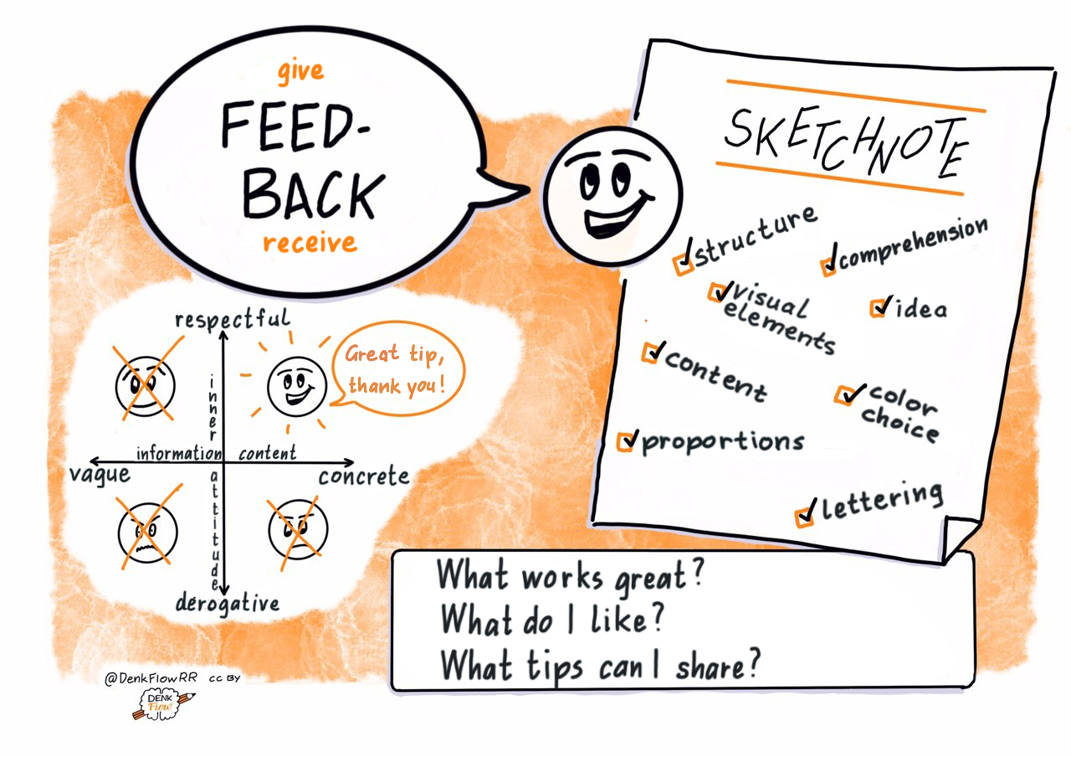

Feedback by @DenkFlowRR CC-BY

An essential function of the circle is to get feedback on your goals and sketches and to give feedback to others. To help you understand each other better, take a few moments to talk about your idea of constructive feedback, including the question “Why do you visualize? And the principle”Compare yourself with yourself".

**More information:**

* Brandyfesto: [Drawing as a thinking tool](http://www.graphicfacilitator.com/brandyfesto/Brandyfesto_112211.pdf)
* Doug Neill: [Sketchnoting is a superpower](https://www.youtube.com/watch?v=lQft0_nL9eI)
* Video: Doug Neill: [How to critique your sketchnote](https://www.youtube.com/watch?v=BPHA2-uxBto)

**Objective:**

* You set up a safe space for giving and receiving feedback.

## Kata 4: My goals for the next 4 weeks

Used in Week 1

What do you want to achieve in the next twelve weeks? Choose a goal that is really important to you and where you can make progress in the sprint. Especially for sketchnote beginners*, reaching the goal is not the top priority. The focus is not only learning the primary know-how, such as the acquisition of your own visual ABC’s, but regularly practicing the newly acquired skills. And finally, the main thing is: have fun :-) To achieve optimal learning success, it is nevertheless vital to set yourself goals that motivate you and with which you can make your progress tangible and visible. You will set your goals using the SMART formula (see more on this below) or use Google’s OKR method to define your goal or purpose. Think about whether you might want to work towards a specific product. This could be, for example, a sketchnote workshop for colleagues, your first graphic recording, or, or, or…

Think about how you want to share your progress in the circle. There may not be enough time in the check-in. Is there a way to track your progress in your documentation tool?

**Define goals with the SMART formula:**

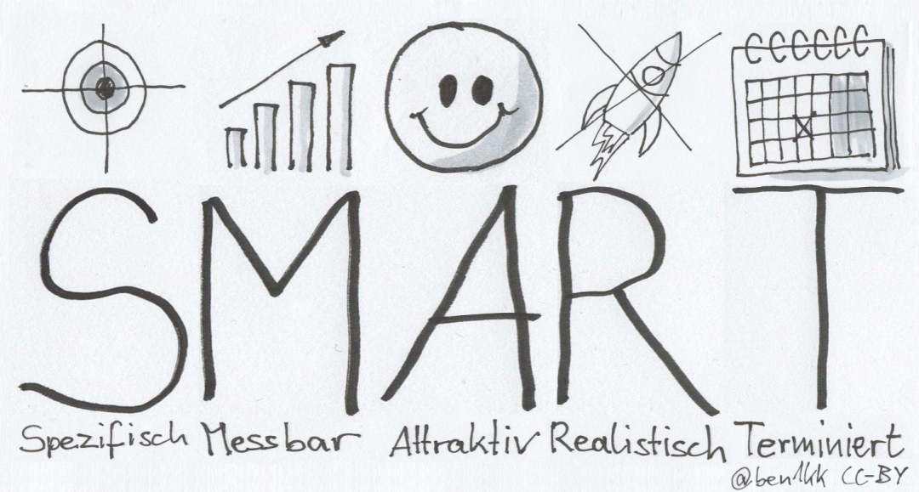

SMART goals by @ben1kk CC-BY

An excellent way to define a goal is to use the “SMART” method. It uses the following criteria.

**S**pecific: Is it clear what you want to do, or is it perhaps too vague? What does or doesn’t it involve? Only if you know exactly what you want to do within the limits of your project can you be sure that you will get where you want to g

**M**easurable: What must happen so that you can say that you have reached your goal? What result do you need to see? For example, if you want to become “better” at something, it is not measurable without formulating “better” more clearly. In this case, you have to ask yourself questions like “Better than what? How exactly do I determine”better"? The first point can already serve you well because the more specific you are in defining your goal, the more likely you are to get a result that you can evaluate.

**A**ttractive: Your goal must motivate you. You have to want to achieve it if you’re going to have the strength to make it come true for 12 weeks. Therefore, this point is especially important. It is best to have a goal that you have personally chosen for yourself and with which you can identify 100%. A goal that others set for you will seldom trigger the same motivation as one that came from your own heart. In some versions of the SMART formula the A also stands for achievable. This means that your goal should not be too easy. You should try a little bit harder and make it more challenging. If you stay in your comfort zone, you can rarely improve. But be careful. Overtaxing yourself doesn’t help, and for most of us this learning path should bring one thing above all: a lot of fun!

**R**ealistic: As symbolized by a crossed-out rocket in the graphic, you figuratively have to stay on the ground when defining your goals. The learning path is 12 weeks, and therefore you should choose a goal that you can achieve in this time. Are you one of those people who likes to make their goals a bit more challenging? Then you should ask yourself once again whether what you have set is feasible. How much time do you have available in a week? Does the whole thing fit into the 12 weeks of the learning sprint? And if you have to say goodbye to one or the other idea, that’s not that bad, because who says that the current Learning Sprint was the last one? :-)

**T**ime-Based: Another critical requirement for your goal is a deadline for completion. In the context of the learning sprint, you can determine this date very precisely. And it’s also important to be able to check, at any time, whether you are still on the right track with your work results, open points, and possible problems or obstacles. Or whether you might have to put more energy into your work on the project or maybe even adjust your goal to be able to reach it. In week 6, we will look at the intermediate results. It’s an excellent time to look at your SMART goal again and, if necessary, readjust it.

**More information:**

* Wikipedia Article [SMART Criteria](https://en.wikipedia.org/wiki/SMART_criteria) (englisch)
* MIT Sloan Article [With Goals, FAST Beats SMART](https://sloanreview.mit.edu/article/with-goals-fast-beats-smart) (englisch)
* Article [OKR – Googles Wunderwaffe für den Unternehmenserfolg oder: Raus aus der Komfortzone](https://t3n.de/news/okr-google-wunderwaffe-valley-ziele-530092/) (german)
* Ted Talk [How We Can Make the World a Better Place by 2030](https://www.youtube.com/watch?v=o08ykAqLOxk) (englisch)
* Video How Google Sets Goals: [OKRs mit Google Ventures Partner Rick Klau](https://www.youtube.com/watch?v=mJB83EZtAjc) (englisch)
* Video [OKR-Agiles Zielmanagement für den Mittelstand](https://www.youtube.com/watch?v=_ugCKONbBNs) (german)
* Video [OKR - Führen mit Objectives and Key Results (OKRs) - so funktioniert das Google Leadership System](https://www.youtube.com/watch?v=y-aIyqMZfnE&t=) (german)
* Book [Introduction To OKRs von Christina Wodtke](https://www.oreilly.com/business/free/files/introduction-to-okrs.pdf) (englisch)
* Book [The Beginner’s Guide To OKR von Felipe Castro](https://felipecastro.com/resource/The-Beginners-Guide-to-OKR.pdf) (englisch)

**Objective:**

* To support your learning success by making your goals measurable.
* To motivate yourself and the other participants by making your goals tangible.

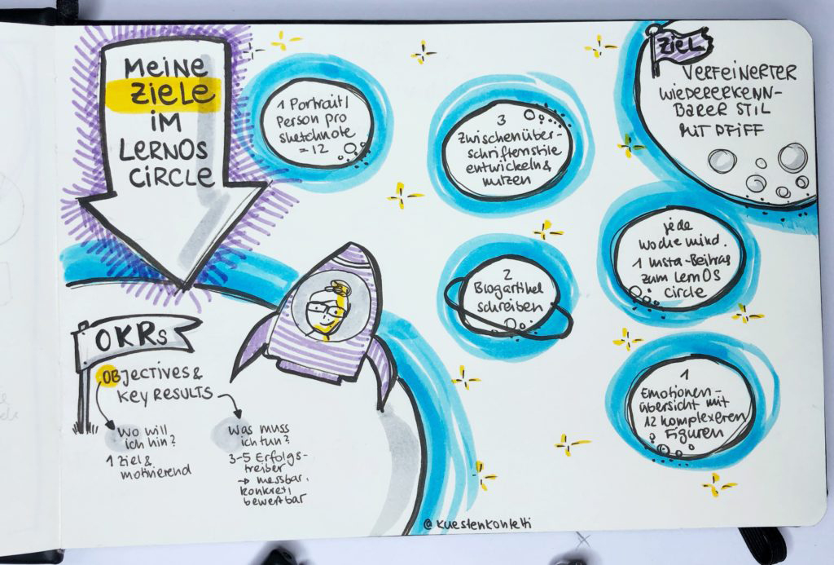

Meine Ziele im LernOS Circle by @kuestenkonfetti CC-BY

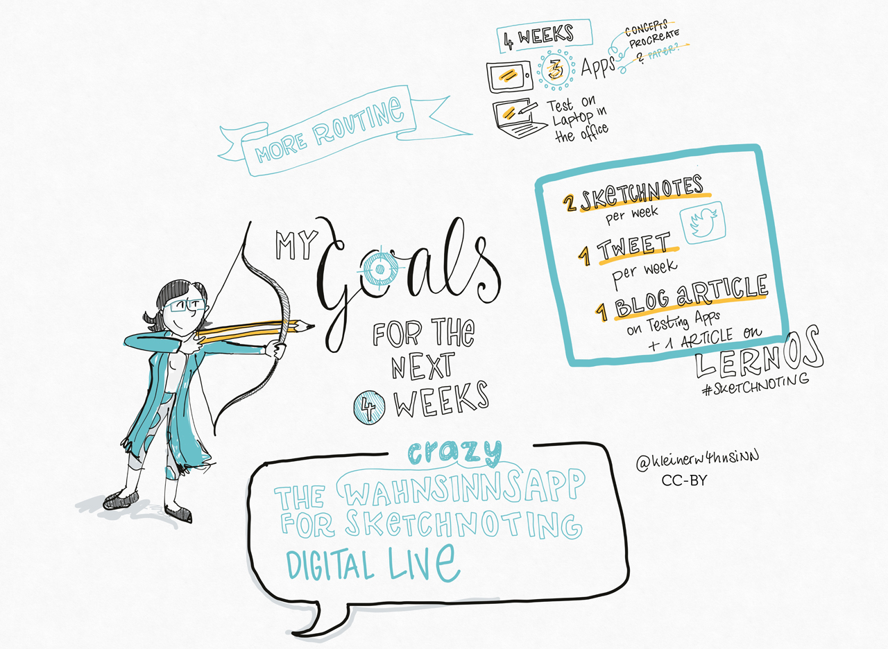

Meine Ziele für die nächsten 4 Wochen by @kleinerw4hnsinn CC-BY

## Kata 5: An appointment with yourself

Used in Week 1

Do you take enough time for your personal development and for working towards your goals? Many people are so busy with their daily lives that they neglect their own progress and well-being. A valuable approach is to make an appointment with yourself and reserve this time in your calendar.

**Practice (15 minutes):**

Check your calendar and look for possible appointments with yourself. An hour or even 30 minutes per week is a good starting point. Make an appointment with yourself on the calendar. If possible, make it recurring so that this time with yourself becomes a habit for you. Find at least five appointments:

1. …
2. …
3. …
4. …
5. …

Discuss your approaches in the circle..

**Further information:**

* Video: [7 Big Rocks](https://www.youtube.com/watch?v=fmV0gXpXwDU)
* Podcast: [Never enough time? Schedule your priorities by colorcoding your calendars](http://www.asianefficiency.com/schedule-management/color-code-your-calendar/)

**Objective:**

* To give yourself the learning space for the exercises.
* To create the necessary conditions to participate in the circle successfully.

## Kata 6: Letter your favourite saying

Used in Week 2

A sketchnote can be designed and structured very well with different fonts and sizes. But often we fall back into our habits when sketching and always use the same old letters.

Take a DIN-A5 sheet (Half of an 8.5x11 in America) and a not-too-long quote of your choice for this kata. Think about which words you want to write in which font and in which size. What is especially important? What emotions resonate? Perhaps you make a small pencil sketch for the proportions and then draw in clean lines. If you need inspiration for fonts, check out the corresponding cards in the Sketchnote Game.

**More information:**

* Video: [How to Write Neatly + Improve Your Handwriting](https://www.youtube.com/watch?v=_QA_NScPlt8)
* Video: [How to Improve your Handwriting | For Note-Taking and Journaling](https://www.youtube.com/watch?v=1YXjAu9o11o)
* Video: [5 tips on how I improved my handwriting](https://www.youtube.com/watch?v=aK2SLQx6j9Q)

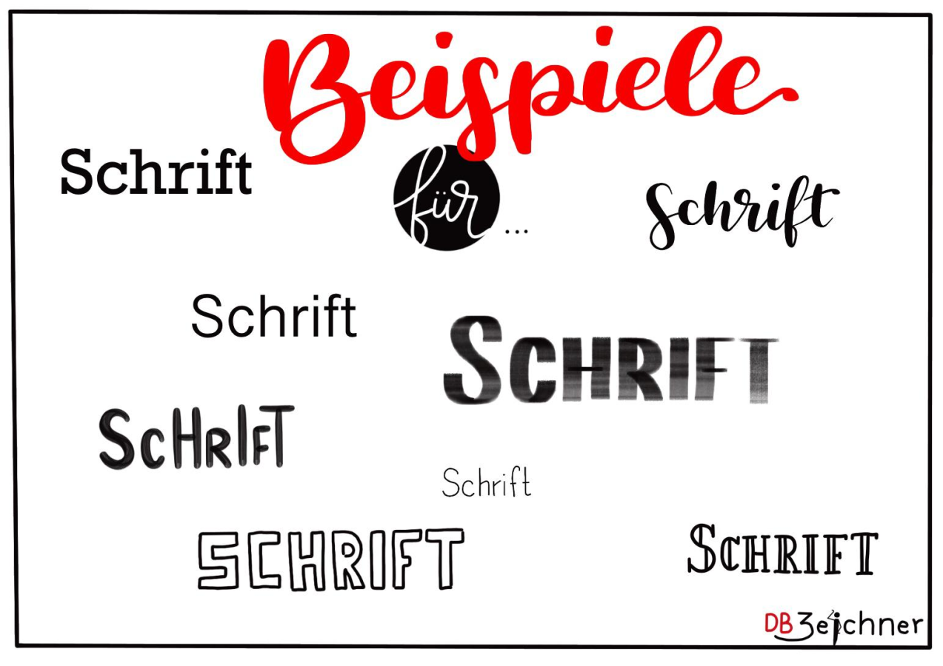

Beispiele für Schrift by @katja.visualisiert CC-BY

**Objective:**

* To recognize which fonts are available in your repertoire.
* To add more new fonts to your repertoire.
* To recognize fonts as stylistic devices and use them accordingly.

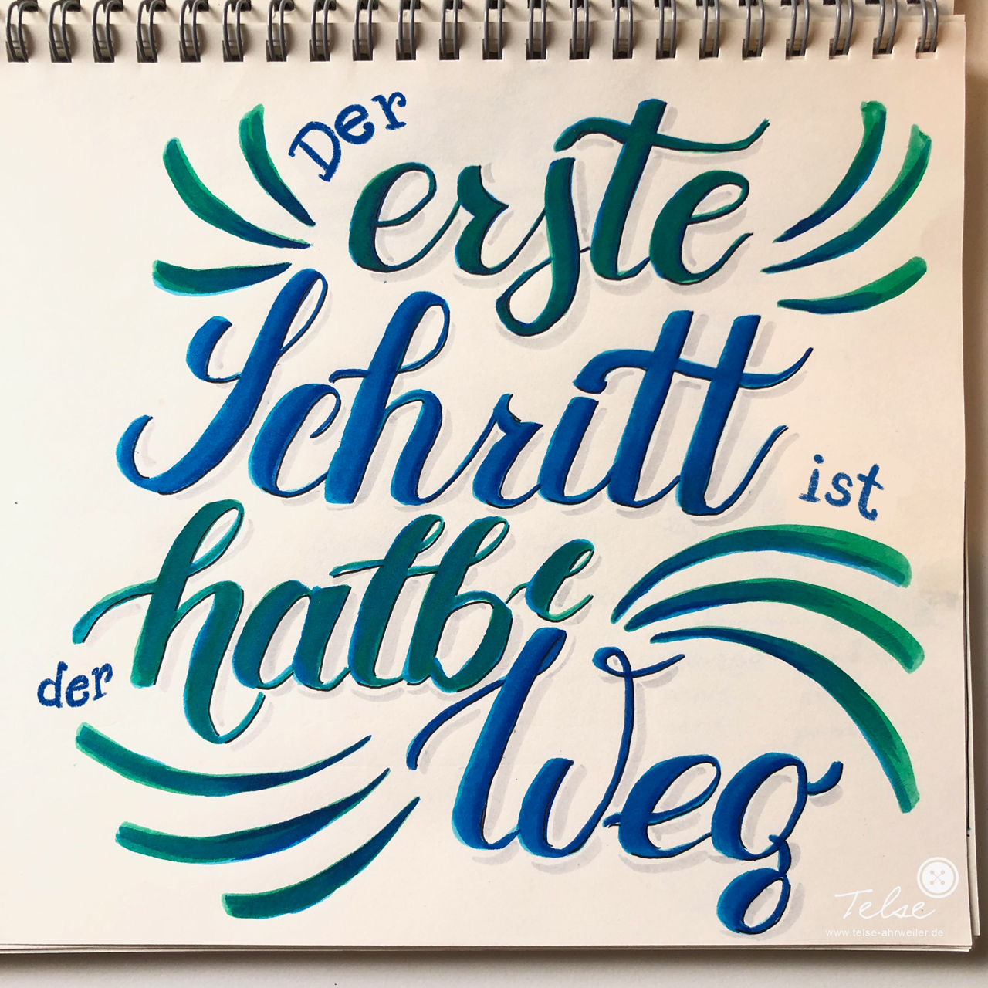

Lettering by @telse_ahrweiler CC-BY

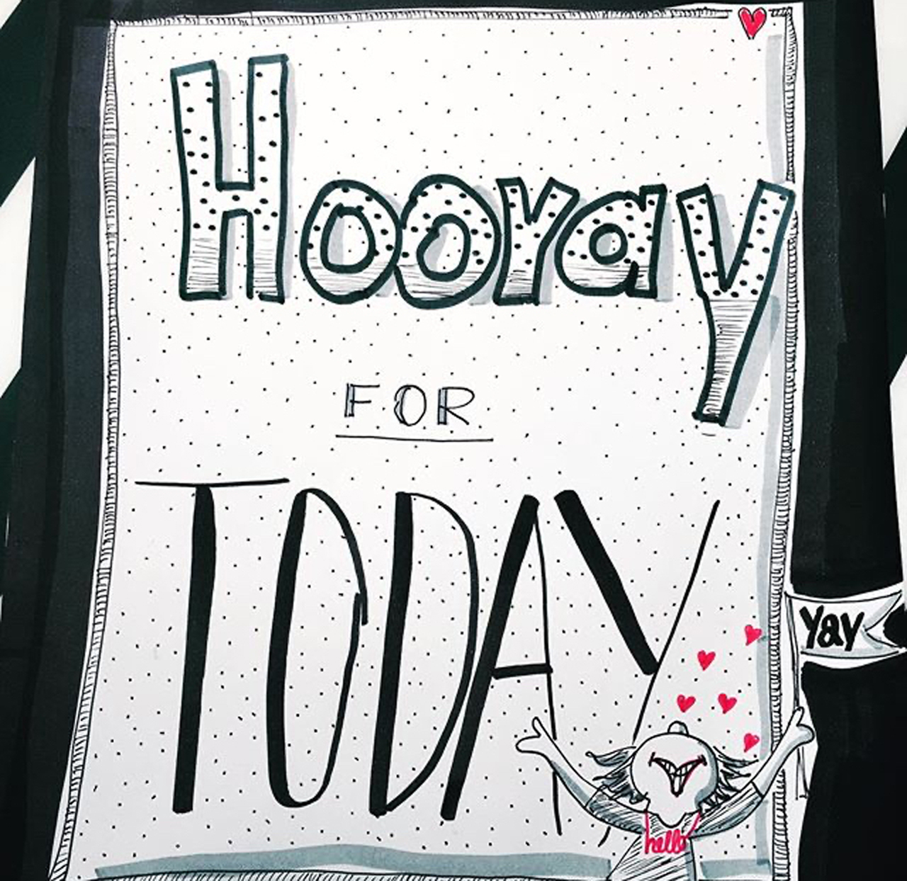

Lettering by @mindfullmindful CC-BY

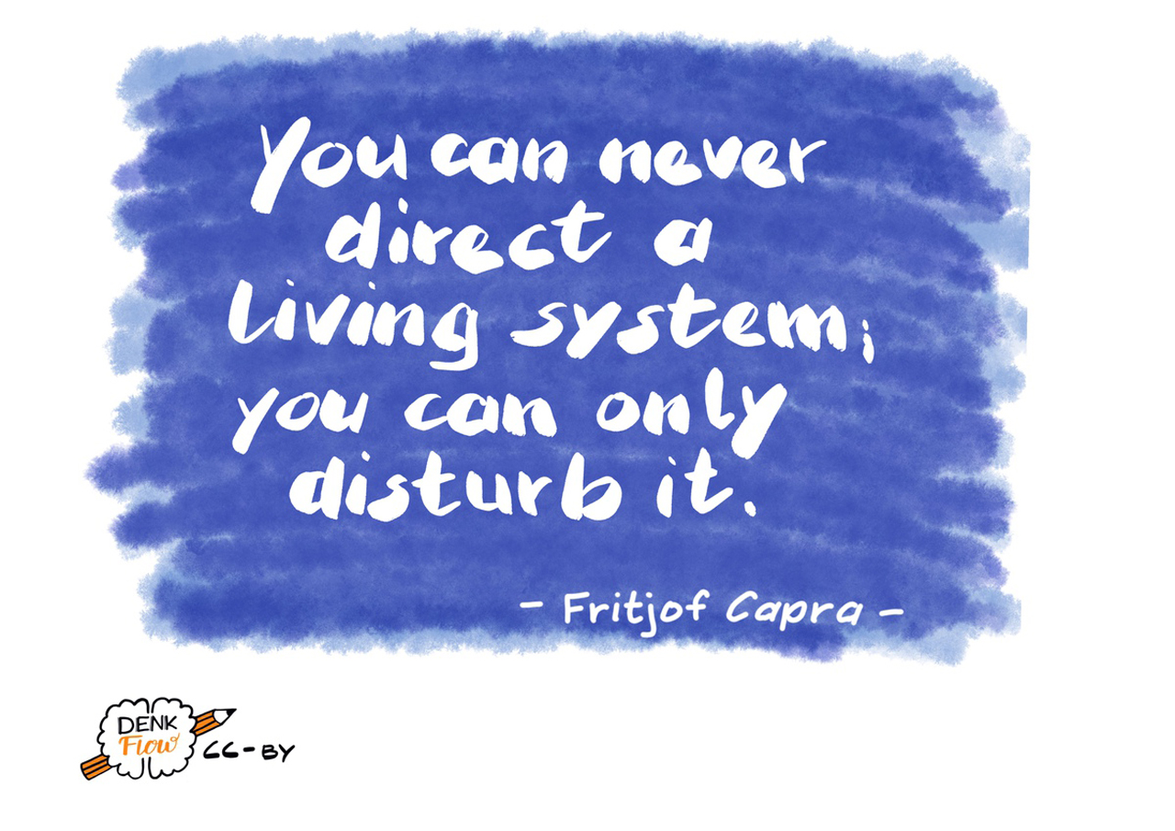

Lettering by @denkflow CC-BY

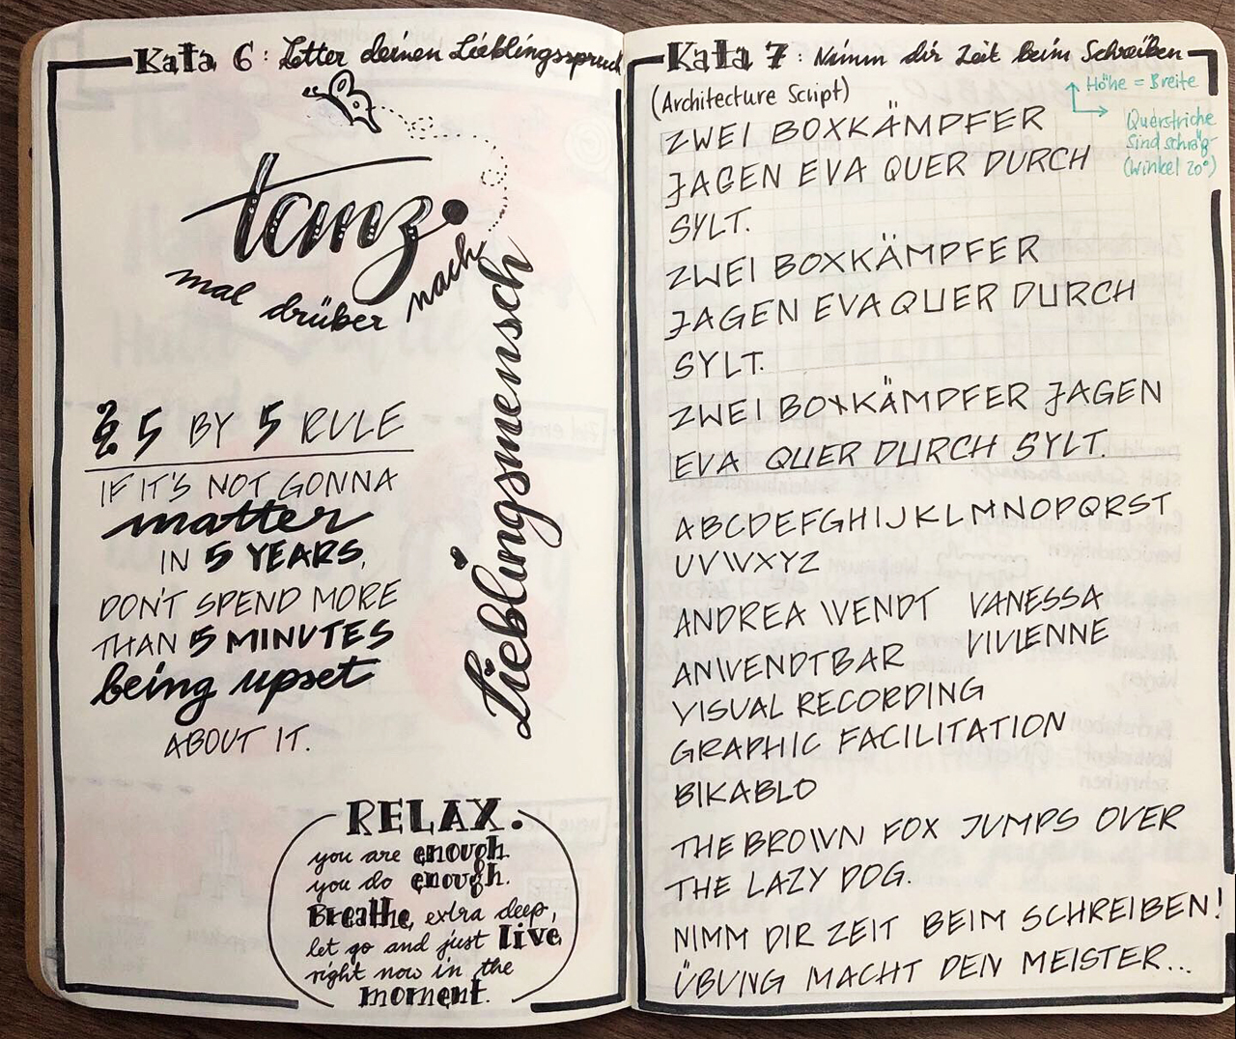

Lettering by @anwendtbar CC-BY

## Kata 7: Take your time while writing

Used in Week 2

A key thing for an excellent sketchnote is its readability. Especially when we tap on keyboards far too much and don’t write much by hand in everyday life, the handwriting practice from primary school is often just a pale memory.

In the appendix, you will find a practice sheet on “Architect’s Handwriting”, which is known for its excellent readability. If you can barely read your own handwriting, you may want to take some time to regularly practice.

Another approach is to take more time to write, and seeing how it affects your readability. To do this, write a short sentence in your normal handwriting, noting the how long it took. Then write the same sentence again, taking twice as much time and maybe even more than that. Look at the letters carefully. What changes? Accelerate again gradually and try to keep the positive changes.

**More information:**

* Blogpost: [How to Write Like an Architect: Short Primers on Writing with the Neat, Clean Lines of a Designer](http://www.openculture.com/2018/02/how-to-write-like-an-architect-short-primers-on-writing-with-the-neat-clean-lines-of-a-designer.html)

**Objective:**

* To recognize the success factors for making your handwriting readable
* … and use them.

## Kata 8: Shopping list

Used in Week 3

Create a shopping list with sketchnotes instead of words, or sketchnote a template for a shopping list. Record the things you buy frequently. Think about the following categories: vegetables, fruits, animals, beverages, groceries, and drugstore items. In such a template you only have to enter the number of things you want to buy.

**Objective:**

* To draw your first symbols in private to reduce inhibitions.
* To repeat the drawing of symbols and icons to train the memory muscle.
* Collect first symbols for your symbol library.

**More information:**

* Pinterest-Boards: [Sketchnote Recipe 1](https://www.pinterest.de/nadrosia/sketchipe-sketchnote-rezepte/) and [Sketchnote Recipe 2](https://www.pinterest.de/kuestenkonfetti/sketchnotes-rezepte/)
* Website: [Illustrated recipes “They Draw & Cook”](https://www.theydrawandcook.com)

## Kata 9: Picture Collection

Used in Week 3

Create an image library for your topics. Note 10 keywords from your subject area. And now search in your surroundings, in books, in pictures, and media for ideas for your presentation. Draw different variations or just one. Choose what suits you best. Save it to your collection.

Present your ideas in the weekly and discuss them in the circle. Discuss where you found the best ideas.

**More information:**

* Website: [The noun project](http://www.thenounproject.com) - free online database with icons
* Video: Doug Neill: [How to expand your visual language - Build up from basic icons to more complex representations of ideas.](https://www.youtube.com/watch?v=z8UkHGpykYU)
* Website: John Atkinson - [Cartoons for Sketchnotes](https://wronghands1.com/)

**Objective:**

* To collect further symbols for your own library.
* To learn your personal approach to creating symbols.
* To receive suggestions for a diverse vocabulary of images from the other participants.

## Kata 10: What do colours mean to you?

Used in Week 4

Colours convey emotions more directly than any layout. Answer the following questions for yourself.

* Which colours do you like?
* Which colours do you use for your sketchnotes?
* Do you use colours consistently?
* What functions do colours fulfil for you?
* How can you use colours as code?

Share and compare your results.

* Are there differences in perception?
* Does this change anything for you?

**More information:**

* Video Brandy Agerbeck: [The color spectrum](https://www.youtube.com/watch?v=s5h0wOtEWcg)

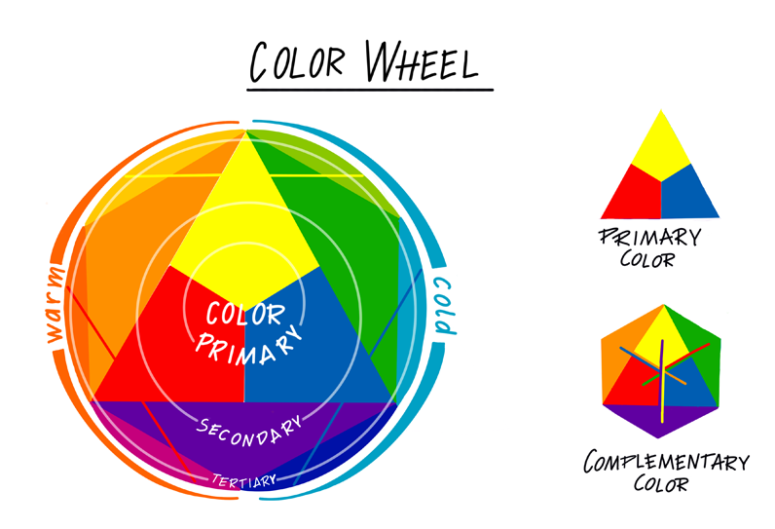

Color Circle by @DenkFlowRR CC-BY

**Objective:**

* To reflect which colours you use and how you use them.
* To get suggestions from the other participants on how they use colours.

## Kata 11: #NeverEnoughPens

Used in Week 4

You can never have enough pens ;-) But to begin, one black,one grey and an additional colour are enough. Have a look at other sketchnotes and plan for yourself which pens you need. With which line thickness can you draw and write with best? Which colours suit your themes? Draw individual motives with different pens and find your own style.

Exchange ideas with each other:

* Where and how do you place shadows?
* How can colour convey meaning?

**Objective:**

* To learn which pen has what effect.
* To learn which colours have what effect.
* To know what types of shadows there are, how to draw them, and how they act.

## Kata 12: 1 sketchnote, 5 colours

Used in Week 4

Prepare a sketchnote in black. Make multiple copies of it and prepare your colored pens. In the weekly, color your sketchnotes together in different ways.

**Suggestions for this:**

* Color as usual.
* Color in the total opposite of your typical style
* Color according to an emotion
* Use color excessively
* Use color only for one single highlight
* Use colour as a hierarchical aid

**Objective:**

* To see the effect of the colour selection in direct comparison.
* To get clarity about which colour combinations work.
* To get inspiration for new colour combinations.

## Kata 13: Layouts for Sketchnotes

Used in Week 5

**Preparation:**

Look at the cheatsheet and think about which layout is best suited for which context or topic.

* Which of these layouts are you already using?
* Which layout have you always wanted to use?
* Practice your containers!

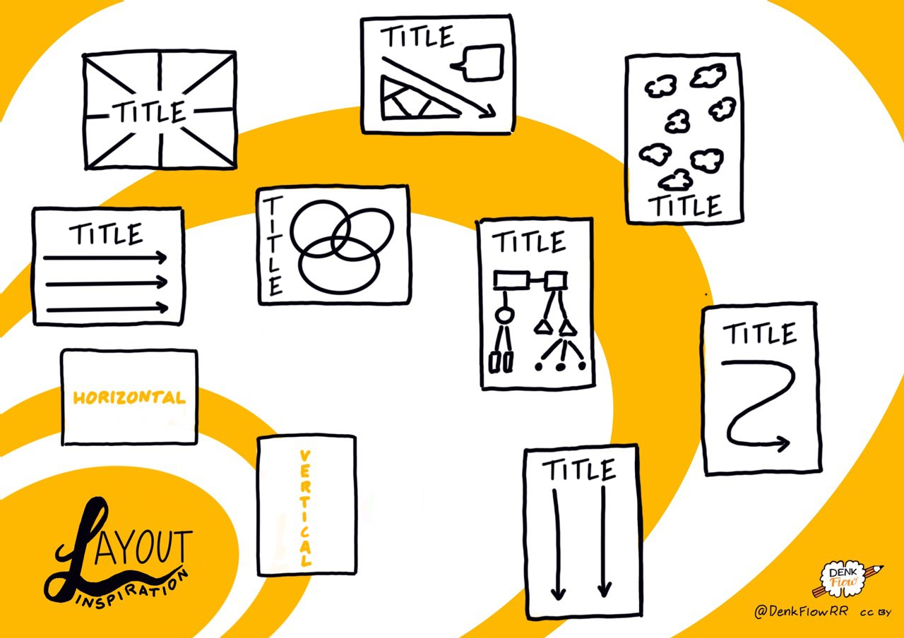

Layout Inspiration by @DenkFlowRR CC-BY

**Objective:**

* To become familiar with layout alternatives.
* To know which layout alternatives are good for what.

## Kata 14: Videosketching

Used in Week 5

Agree on a video that you want to sketch together live. We recommend something under 10 minutes, maybe an episode of “Sendung mit der Maus” (informative German kids’ tv show). If you meet online, try to set up your cameras to show your sketchnotes.

**In the weekly:**

Watch the video together and sketch the content. Then compare your sketchnotes.

* Which layout did you choose why?
* Were you able to implement the layout as planned?
* Does the result correspond to your plan?
* Is the layout understandable for the others?
* What would you do differently next time?
* Are you missing a layout idea on the cheat sheet?

**Video suggestions for live sketching**

In English with German subtitles:

* [Julian Treasure - How to speak so others want to listen](https://www.ted.com/talks/julian_treasure_how_to_speak_so_that_people_want_to_listen?language=en) (9:54min)
* [Will Smith - Skydiving in Dubai: Fear only ruins your day!](https://www.youtube.com/watch?v=W1sF1sgUeTU) (2:24min)

In German:

* [Where does the German national flag come from? I musstewissen kompakt](https://www.youtube.com/watch?v=XQmJve3yD9Q&feature=youtu.be) (3:36min)
* [How do the stripes get into the toothpaste? – Factual stories with Armin Maiwald](https://www.youtube.com/watch?v=Pius1MtUIrY) (4:34min)
* [“Die Sendung mit der Maus” – noodle production (factual stories) 1976](https://www.youtube.com/watch?v=95XER5t2xn0&feature=youtu.be) (5:07min)

**Objective:**

* To recognize which layout supports video sketching.
* To reflect on your approach to creating a sketchnote.

## Kata 15: Presenting your intermediate result

Used in Week 6

Present your first product (Minimal Valuable Product) OR do a rework of your Sktechnote-Selfie!

If you are working on a specific product, you can use this Weekly to present your Minimal Valuable Product to others.

Your goals: Bring your OKR metrics!

* What progress are you making in your key results?
* What are you planning to do?
* Where do you want to go?

If you’re not working on a product, you could, for example, do a rework of your sketchnote selfie with the techniques you’ve been practicing for the previous six weeks.

* Do you see any differences?
* Do the other Circle members see any differences?

You can use the following additional questions to reflect on the intermediate result:

* Our cooperation: What do you appreciate about our collaboration? For what do you wish for more support?
* Golden moments: What were eureka-moments in the previous learning path for you? Which “treasures” have you already lifted?

**Objective:**

* To recognize what progress you have made and whether a goal adjustment is necessary.
* To receive feedback from the participants on your project and can use it directly.
* To receive feedback on the extent that your sketchnote skills have developed.

## Kata 16: Videosketching: Did you get it?

Used in Week 6, Week 7, Week 8

Split up into teams of two. Both of you choose a short video on an exciting topic and sketch it (without telling us what you are sketching). Then share the result with your Circle Member. He or she will first look at the sketchnote and then watch the video.Prepare your feedback; either make a one-on-one appointment or share your feedback with the Circle.

**Key questions for analysis and feedback:**

* What makes the sketchnote easy to read? Where is there still potential?
* What makes the sketchnote understandable? What is missing?
* What appeals to you about the sketchnote? What is particularly well done?
* What essential information do you find in the sketchnote, and what are you missing? How is the information presented? How does this appeal to you?
* Which elements help to give the sketchnote structure? Could any additional elements have been used to support this?

**Objective:**

* To practice creating a sketchnote using a video.
* To understand what you do well when creating a sketchnote.
* To get feedback on your existing sketchnote potential.

## Kata 17: Feedback on content

Used in Week 8

For sketchnotes, active listening and capturing the essential information (core theses), for example a lecture, is critical. This Kata is about actively asking for feedback on your Sketchnote from the outside.

Depending on the setting in which you create your sketchnote, there are different ways to get feedback. Here are a few examples:

1. Sketchnote created at an event:

Why not go directly to the presenters and event organizers and ask them for feedback on the content of your sketchnote? Was the information fully collected? Are the core theses included?

If there are multiple sketches from different sketchnoters of the presentation, you could compare the informational content of the sketches and rate the information you gathered.

1. Sketchnote created at a meeting:

At the end of a session, you could ask participants to provide feedback on your sketchnote. Are the participants of the opinion that you’ve captured the key points from the meeting and weighted them appropriately?

1. Sketchnote created about a trip:

Ask your travel companions, such as family or friends, whether their experiences and impressions resonate in your sketchnote.

1. Sketchnote created about a particular topic:

You could post your sketchnote on social media and ask for feedback. Ask concrete questions about what you want to get feedback on.

* Share with your circle the experiences about how to get feedback on the content of your sketchnote (20 minutes).
* Talk about your findings and reflect on how feedback on the content of your sketchnote can help you improve your skills.

**Objective:**

* To practice your sketchnote skills in a business context and expand your comfort zone.
* To know what you can do well when creating a Sketchnote.
* To know where there is still potential.

## Kata 18: Top 5 Resources

Used in Week 8

You may have had time to look at the resource list at the end of the guide.

* What did you particularly like?
* Is there something missing that inspired you, or something that lets you see sketchnoting from a completely different perspective?

Write down a list of your top 5 and present your lists in the weekly. Find a way to show the lists to each other.

**Objective:**

* To get an overview of other sources of knowledge on the Internet.
* You will realize which sources are useful for you.

## Kata 19: Soulshine-Selfie

Used in Week 9

What are you personally thankful for in your life? It can be things, people, but also situations or special memories? Do you think about the sunny side of life and beautiful things often enough? We all experience it far too often and we forget the happy moments far too quickly. We tend to only concentrate on our problems.

**Exercise (30 minutes)**

Create a sketchnote of things you like, love, and simply appreciate in your life. Draw yourself in the center, e.g. in front of a “sun” and arrange your “sources of happiness” around it. Give each of them a caption or a short text. Thereby you will benefit from the “Dual-Encoding Theory” and keep them better anchored in your memory.

Check out the [#SoulshineSelfie Posts](https://www.instagram.com/explore/tags/soulshinekalender/) on Instagram or the [story behind them](http://www.vizworks.de/soulshine-kalender/) for inspiration.

**Leitfragen:**

* What do you feel when you look at your Soulshine-Selfie?
* Can you imagine following this exercise over a more extended period?

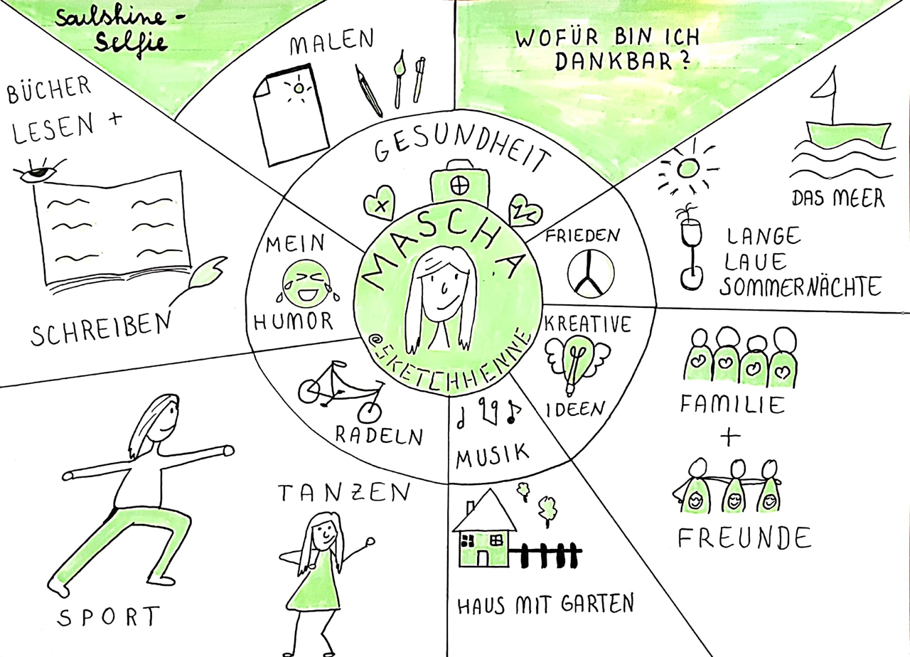

SoulshineSelfie by @sketchhenne CC-BY

**Objective:**

* To practice humility and gratitude.
* To make transparent the things that consciously make you happy in your everyday life.
* To practise using visual language to depict circumstances.
* To practise layout design.

## Kata 20: Reflections - Sketchnote (Part 1) “Thoughts on Structure”

Used in Week 9

You’ve come a long way by now. Well done! To record your learning experiences, a sketchnote as a summary can be very beneficial. To make the process of creating this sketchnote conscious, we would like to ask you to take the following steps first:

* Make three layout drafts for your sketchnote which will reflect your experiences in this sprint.
* Select one of the layouts.
* Show your sketches in the weekly. Why did you make this choice?

**Objective:**

* To repeat possible layout alternatives for sketchnotes.
* To understand which layout alternatives support your content in a way that is appropriate for the target audience.
* To get suggestions and feedback from the circle members to make your sketchnote even more appealing.
* To reflect on what you have learned and the experiences you have made so far.

## Kata 21: Reflection sketchnote (part 2) “The structured path”

Used in Week 9, Week 10

You have now decided on a layout for your reflection sketchnote. Finish drawing the draft sketched in Kata 20 and share it with the others.

**Key questions for analysis and feedback:**

* Repetition: Why exactly did you choose this structure?
* How did you aim to create a sketchnote that was readable, informative and appealing? Did you focus on anything in particular?
* What are your most valuable learnings from this sprint?
* How do you plan to use these results further?
* Was there a lernOS-Eureka moment in this sprint? If so, what was it, and why?

**Objective:**

* To learn to distinguish between what is essential and what is not: What do I want to bring across?
* To know the success factors for creating an informative and appealing sketchnote.
* To will create a coherent sketchnote.
* To know your learning success within the lernOS Sketchnote Circles.

## Kata 22: Pictionary (originally “Montagsmaler”)

Used in Week 10

The “Montagsmaler” was a programme on German TV, in which several team members guessed terms that a member of the team had drawn. To start this exercise, you need some terms that represent specific things, such as train or elephant. Make sure to pick concrete nouns that are not abstract. This online Thesaurus can randomly select words, so you can use it to support word-finding:

<https://www.palabrasaleatorias.com/zufallige-worter.php>

also available in English:

<https://www.palabrasaleatorias.com/random-words.php>

In turn, each Circle Member picks a word and draws it, the others guess what it is. The aim is to draw something, to overcome the inhibition of drawing and above all, to find out how little it often takes to make a word clear. This exercise is therefore particularly suitable for a “warm-up” after the first exercises. It is also an excellent task later on when your skills are growing. Then verbs that show figures in action, such as walking, dancing, or thinking, become very useful.

**Objective:**

* You will get feedback on the recognizability of your drawing: What is essential for something to be recognized?
* To learn to overcome your inhibitions of drawing.
* To repeat what you have learned and apply it in combination

## Kata 23: Measure & show your success

Used in Week 11

Congratulations! You have arrived at the final Kata of this circle. Now it is time to measure your success over the last few weeks and make it show.

If you have worked on a product as a project, then finalize it. Look back to where you started. What challenges have you mastered while creating the product?

You didn’t work on a specific product? Then look back at the last weeks in the circle. What has mainly influenced or moved you in the past weeks?

You can use the spider web graphic in the appendix to show your progress. Think about different areas, such as layout/structure, picture vocabulary, live sketching. Then estimate on a scale of 0-10: Where did you stand at the beginning of the circle? Where are you now? That way you can visualize your progress.

If you have worked with OKRs for your goals, evaluate their progress. For example, use the OKR tracking chart in the appendix.

And don’t forget: Congratulate yourself for this circle and the last few weeks!

**Objective:**

* To get clarity regarding your goal achievement.
* To will get feedback from the Circle Members to build up on this.
* To celebrate your successes!

# **Warm-Ups**

## “Kringel” or Squiggle birds (week 0)

Step 1: Draw as many random squiggles as possible on a sheet of paper within one minute.

Step 2: If you work in pairs: swap your sheets, if you are alone (in front of your screen), then continue with your squiggles.

Take a second, different coloured pen and add some beaks, legs, wings, or add shadows and shades if you like.

Step 3: Show your squiggle-bird collection to the others. Maybe you want to share it later on Twitter or Instagram?

**More information:**

* Video: [Dave Gray - Squiggle birds](https://www.youtube.com/watch?v=vK3yQBouzNs)
* Video: [Hirameki - draw what you see](https://www.youtube.com/watch?v=IrLwkyWBB7w)

## Goals (week 1)

How do you visualize goals? Draw icons and compare them. How do you visualize that the goals have been achieved?

## Very big and very small (week 2)

Agree on a word. Everyone writes it with a thick pen, first in really big letters and then in really small letters. Then change the pen and write the word with a thin pencil first very small and then very big. Compare the results: How do you make everything readable and also look good? (5 minutes)

## Icons (week 3)

Everyone brings along a word that they find exciting or challenging to visualize. All words are sketched in 30 seconds each and then compared. (5 minutes)

*Option 1: Compare the results with the #20secchallenge in the Sketchnote Army Slack* *Option 2: Tell a mini-story out of the 5 words*

## Fewer details, please (week 4)

Remember to share with the circle your favorite icon from last week.

*Option 1: Everyone draws the same icon in 30 seconds, then in 15 seconds, then in 5 seconds. Compare the results.*

*Option 2: Draw the icon once with a normal pen and then with a much thicker pen. How do you make the icon well recognized?*

## Container (week 5)

Draw various containers and discuss what they are suitable for. (For example, a cloud stands for an idea rather than a result or a decision).

## Warm-Up (week 6)

Pair up and draw your counterpart (via webcam) without looking at your sheet and focus on essential features. Time: 30 seconds. Zeit: 30 Sekunden *Option 1: You can pick up the pen and put it back down as normal.* *Option 2: Draw without lifting the pen from the sheet, i.e., with one continuous line!*

## Draw Toast (week 7)

The exercis “[Draw Toast](https://www.drawtoast.com/)” was created by Tom Wujec, who calls it an “Introduction to Systemic Thinking and Wacky Problem Solving”. Here you use it as a warm-up for today’s weekly, so it’s a little shortened. The process is simple:

1. Have pen and paper (or respective digital tools) ready.
2. Draw a sketch of how to make toast – in 3 minutes!
3. Show each other your results, maybe ask yourself the following questions:
   * Which sketchnote is simple, which is complex?
   * Where do you see people, where don’t you?
   * What similarities and differences can you find?

If you like “Draw Toast”, Tom has posted it on CC-BY-SA at https://www.drawtoast.com/ You can use it to open meetings and workshops if you go through the whole process. Maybe you can even introduce newcomers to sketchnoting.

## Process (week 8)

Sketch the sequence of your morning routine of the current morning (until leaving home) or from the way to work.

## Visual communication makes the difference (week 9)

Step 1: A person draws a circle, triangle, and square on a piece of paper. Without showing the picture, they now describe the image. The others draw the picture following the explanation. Afterwards, everyone shows their pictures. In the first round no questions are allowed.

Step 2: Repeat the exercise, but clarifying questions may be asked.

## Figures in action (week 10)

Draw different types of characters and show them to each other.

Agree on 5 activities and draw your characters in action. Compare how you have visualized the activities!

More information: [Sketchnote Game Chapter Figures](https://sketchnotegame.files.wordpress.com/2017/08/sketchnotes_a6-figuren.pdf)

## Emotions (week 11)

Continue with the characters - help them show emotions!

*Option 1*: Everyone draws different emotions, expressesing them by characters’ body postures. Share your results and have others guess which emotion was represented.

*Option 2*: Experiment with the face generator of the Sketchnote game and express different emotions through facial expressions!

Further information: [Sketchnote Game Chapter Figures](https://sketchnotegame.files.wordpress.com/2017/08/sketchnotes_a6-figuren.pdf)

## Special features (week 12)

Collect different eyes, noses, hairstyles, glasses, beards… and other features (clothes, accessories). Share and compare your collections.

Play a round of Human-O-Mat or generate the ingredients for bizarre characters yourself!

More information: The [The Human-O-Mat](https://www.ein-bild.com/menschomat) by Sandra Martin [@Sam_HH](https://twitter.com/sam_HH) generates the “ingredients” at random.

## More warm-ups to choose from

**Apples** Draw as many things as possible that contain the word “apple”. Or agree on another word.

More info: Based on https://www.tbd.community/de/a/3-kreativitaetsuebung-team

**Story Cubes** If any of you have Storycubes dice, use them to tell a short visual story. Alternatively, you can use a random word generator for several words. Make sure they’re nouns.

Generators: - The app “Inspire me,” allows you to create your own word lists. (Only for Apple devices). - A random word generator: https://randomwordgenerator.com/ - TVtropes.org has a generator that focuses on stories. https://tvtropes.org/pmwiki/storygen.php

**Circles** Which pictures come to mind that contain a circle as a primary form? Draw them and compare your results! Find an A4 template PDF with 15 circles in the attachment.

# **Resources**

## Videos

**Brandy Agerbeck -** [**The essential 8**](https://www.youtube.com/watch?v=3sXsXveYQtc)

The thought of drawing in front of other people can be intimidating. Brandy Agerbeck breaks down drawing in the context of Graphic Facilitation (moderation with visualization) into 8 essential components. All visual practitioners can use this video. It helps you to focus on the essentials and to bring your ideas from a picture in your mind to the paper. (English)

**Brandy Agerbeck -** [**what is visual thinking?**](https://www.youtube.com/watch?v=Yr6DN20NHvs)

What is visual thinking? Not an instructional video, more a “why should I?” video. hy drawing is such a fantastic thinking tool and why Brandy focuses on THINKING in visual thinking. (English)

**Karen Bosch -** [**Sketchnote elements**](https://www.youtube.com/watch?v=sH-sJXMQjro&feature=share)

Overview of the essential elements of a sketchnote. (English)

**Willemien Brand -** [**VISUAL THINKING**](https://www.youtube.com/watch?v=pUelkBYu9jU)

Visual thinking - integrating visualizations into business communication

Willemien presents a webinar in which she explains the meaning and purpose of visual thinking in a business context. It includes a short live business drawing workshop. (English)

**Sunni Brown -** [**Doodlers, unite!**](https://www.ted.com/talks/sunni_brown?share=11cb8401a9&language=en)

Studies show that sketching and drawing improve our understanding - and our creative thinking. Why are we still embarrassed when we get caught doodling in a meeting? Sunni Brown says: Doodlers, unite! She advocates freeing your brain with paper and pencil! (English)

**Kate Hayward -** [**Draw like a child, see like a master**](https://www.youtube.com/watch?v=ZA92l6KwuT4)

Draw like a child, see like a master.

Hayward explains how seemingly simple drawing techniques can allow us to communicate more clearly by building an extensive visual vocabulary of simple, childlike images. (English)

**Pavo und Rob (Pavo Ivcovic und Robert Bree) -** [**Coffee talk around sketchnotes, lettering… YouTube channel**](https://www.youtube.com/channel/UCY7b7ox2oKeFL61KNRQNGHw)

**Heather Martinez - Neuland Hand 2.0 ::** [**Lettering Tips Tuesdays**](https://www.youtube.com/watch?v=0O8PoYsxaT4)

Neuland Hand 2.0 is handwriting designed for graphic recorders and presenters that works well for titles and headlines. (English)

**Doug Neill -** [**Verbal to Visual YouTube-Kanal**](https://www.youtube.com/channel/UCuFm4ARxn306lX_OWMnz0-w)

YouTube channel by Doug Neill / “Verbal to Visual” with lots of practical tips and instructions on how to learn and use sketchnotes. (English)

**Onda -** [**Visual Thinking Crash Course!**](https://www.youtube.com/watch?v=IdVBjZbqOSk)

A crash course in visual thinking. (English)

**Mike Rohde -** [**Sketchnote mini workshop**](https://www.youtube.com/watch?v=39Xq4tSQ31A&feature=share)

Half-hour sketchnote workshop. (English)

**Scriberia -** [**What is visual thinking?**](https://www.youtube.com/watch?v=rZikhQ5w5Ck)

What is visual thinking? A small animated film. (English)

**Graham Shaw -** [**Why people believe they can’t draw - and how to prove they can**](https://www.youtube.com/watch?v=7TXEZ4tP06c)

Why do so many people think that they can’t draw? Where and when did we develop this conviction? Graham Shaw destroys this illusion in a very pragmatic way. He demonstrates impressively how the simple act of drawing has the power to bring about a positive change in our world!!

## Books

**Brandy Agerbeck - The idea shapers - The power of putting your thinking into your own hands** - The power of putting your thinking into your own hands. Detailed essential work on drawing as a tool for thinking. Very systematic, with 24 “idea shapers,” concepts to design ideas visually. (English)

**Brandy Agerbeck - The graphic facilitator’s field guide/Der Wegweiser für den Graphic Facilitator** - How to create meaning through listening, thinking and drawing. Refers to Graphic Facilitation, Graphic Recording, Visual Moderation / creating visual protocols. (English/German)

**bikablo akademie GmbH & Co. KG, Martin Haussmann - bikablo(R) 1** - The picture-card block as a reference book of visual language with hundreds of picture symbols. (German/English/French)

**bikablo akademie GmbH & Co. KG, Martin Haussmann - bikablo(R) 2.0: New images for Meeting, Training & Learning** - Pictorial symbols from the topics “Workshop/Meeting/Seminar/Training”, “Company/Organization/Market” and others. Tips for professional visualizations and poster layouts. (German/English/French)

**bikablo akademie GmbH & Co. KG, Martin Haussmann - bikablo(R) emotions: Visuelles Wörterbuch** - This visual dictionary focuses on people, their feelings, their living and working together with others. (German/English/French) **Willemien Brand - Visuelles Denken: Stärkung von Menschen und Unternehmen durch visuelle Zusammenarbeit** - Using visual communication successfully in (professional) everyday life. (German/English)

**Willemien Brand - Visual Doing: Applying Visual Thinking in your Day to Day Business** - Focusing on the use of visualization techniques in everyday business. (English)

**Sunni Brown - The doodle revolution** - UUnlock the power to think differently - about the how and why of Doodles (English)

**Ben Crothers - Presto Sketching: The Magic of Simple Drawing for Brilliant Product Thinking and Design** - Tips, templates and exercises for building a visual vocabulary and developing the drawing skills needed to communicate ideas. (English)

**Martin Haussmann - UZMO - Denken mit dem Stift: Visuell präsentieren, dokumentieren und erkunden** - Thinking with the pen: Visual presentation, documentation and exploration: Practical guide for Visual Facilitating with practical drawing instructions. (German)

**Robert Klanten, Anna Lena Schiller, Sven Ehmann - Graphic recording: Eine Anleitung zum Illustrieren von Meetings, Konferenzen und Workshops** - A comprehensive manual with many examples of different graphic recordings. (German)

**Heidrun Künzel - Sketchnotes im Alltag: Schritt für Schritt Sketchnotes anwenden** - Step-by-step instructions for using Sketchnotes in everyday life (to-do and have-fun lists, checklists, plans for holidays, garden, recipes, personal greetings, vouchers, invitations and inspiration for diary and calendar). (German)

**Maja Larsson - Alla kan rita symboler** - In Swedish, but very lively and individual templates and inspirations for figures. (Swedish)

**Giorgia Lupi & Stefanie Posavec - Observe, collect, draw (data visualization)** - A visual “diary” with lots of inspiration to find patterns in your daily life by observing, collecting and drawing (visualization of data). A very vivid, concrete and personal introduction to / experience with data visualization. (English)

**Dan Roam - The back of the napkin/Auf der Serviette erklärt** - Convince quickly with a few strokes instead of presenting for a long time. Solving problems and selling ideas with pictures - very tactical! (English/German)

**Dan Roam - Blah blah blah - What to do, when words don’t work** - Tell exciting stories with illustrations. (English/German).

**Mike Rohde - The sketchnote handbook** - The classic!

**Nadine Roßa: Sketchnotes. Die große Symbol-Bibliothek: 1000 Vorlagen mit vielen Zeichenanleitungen** - 1000 templates with many drawing instructions: Line by line instructions and variations of symbols

**Nadine Roßa - Visuelle Notizen für alles: von Business-Meetings über Partyplanung bis hin zu Rezepten** - Visual notes for everything: from business meetings and party planning to recipes - building sketchnotes, visual alphabet, tips and tricks (German)

**Malte von Tiesenhausen: Ad hoc visualisieren - Denken sichtbar machen** - Making thinking visible: practical instructions and tips on how to use visualization to communicate one’s ideas more understandably and sustainably and as a resource for finding ideas. (German)

**Tanja Wehr - Die Sketchnote-Starthilfe** - Over 200 line-by-line instructions and fonts for tracing (German)

**Tanja Wehr - Die Sketchnote-Starthilfe Neue Bilderwelten** - Extensive business and sketchnote picture vocabulary: Over 300 new picture words (German)

## Communities

[Sketchnote Army](https://sketchnotearmy.com/) [Slack channel](https://sketchnotearmy.com/slack)

Sketchnotes Germany on [Facebook](https://www.facebook.com/groups/sketchnotesgermany/)

## Inspiring People / Newsletter / Social Media Accounts

Brandy Agerbeck - [Twitter](https://twitter.com/loosetooth)

Katharina Bluhm - [Twitter](https://twitter.com/kuestenkonfetti) [Newsletter](https://katharinabluhm.de/newsletter/)

Marc Bourguignon - [Twitter](https://twitter.com/100978Marc)

Sunni Brown - [Twitter](https://twitter.com/SunniBrown)

Prof. Michael Clayton - [Twitter](https://twitter.com/ProfClayton)

Ben Crothers - [Twitter](https://twitter.com/bencrothers)

Rob Dimeo - [Twitter](https://twitter.com/Rob_Dimeo)

Karen Forkish - [Twitter](https://twitter.com/kforkish)

Magalie Le Gall - [Twitter](https://twitter.com/magalielegall)

Marcel van Hove - [Twitter](https://twitter.com/marcelvanhove)

Pavo Ivcovic (Djangonaut) [Instagram](https://www.instagram.com/djangonaut/) - Instagram Live Talk / Fr at 9:30 am (coffee talk with Pavo and Rob) Instagram [#pavoundrob](https://www.instagram.com/explore/tags/pavoundrob/) - Sketchnotes zu den Coffee talks

Austin Kleon - [Newsletter](https://austinkleon.com/newsletter/)

Eva-Lotta Lamm - [Newsletter](https://sketchnotesbook.us2.list-manage.com/subscribe?u=6002ba391bca80877955f964d&id=2ba2f4f8a3), [Instagram](https://www.instagram.com/evalottchen/)

Gary Lau - [Twitter](https://twitter.com/PastorGaryLau)

Katrin Mäntele (Der kleine Wahnsinn) - [Twitter](https://twitter.com/kleinerW4hnsinn)

Sandra Martin - [Twitter](https://twitter.com/sam_HH)

Doug Neill - [Twitter](https://twitter.com/douglaspneill)

Dr. Makayla Miranda Lewis - [Twitter](https://twitter.com/maccymacx)

Holger Nils Pohl - [Twitter](https://twitter.com/HolgerNilsPohl)

Marianne Rady - [Twitter](https://twitter.com/MarianneRady)

Katja Reiter - [Instagram](https://www.instagram.com/katja.visualisiert/)

Nadine Roßa - [Twitter](https://twitter.com/nadrosia)

Linda Saukka-Rauta - [Twitter](https://twitter.com/saurau)

Sketchnote Army - [Twitter](https://twitter.com/SketchnoteArmy)

Diana Soriat - [Twitter](https://twitter.com/DianaSoriat)

Nick Sousanis - [Twitter](https://twitter.com/Nsousanis)

Ania Staskiewicz - [Twitter](https://twitter.com/AniaStaskiewicz)

Prof. Katharina Theis Bröhl - [Twitter](https://twitter.com/theiskbt)

Malte von Tiesenhausen - [Instagram](https://www.instagram.com/malte_von_tiesenhausen/)

Mauro Tosselli - [Twitter](https://twitter.com/xLontrax)

Tanja Wehr - [Instagram](https://www.instagram.com/sketchnotelovers/)

# Stop talking. Start doing!

If you have read this guide, but have not yet actively implemented lernOS, you should start now! Starting with lernOS is easy. These five steps will help you to get started smoothly:

1. Make time: Define when you want to start with lernOS. Enter the times for the weekly in the calendar. This regular appointment is especially necessary if you practice lernOS in a circle.
2. Define goals and key results: Use week 0 to set your goals and measurable results for the sprint. Choose a goal that you really care about.
3. Start a circle: Look for 3-4 allies who want to start a sprint at the same time. If someone has already been in another circle, that person can take over the role of Circle Moderator.
4. Organize the weekly: if you do not know each other in the circle, it is best to meet in week 0 in person. (This advice must be put on hold during the COVID-19 pandemic.) Use social networks or messengers to communicate between meetings. Use video conferencing to organize virtual meetings.
5. Plan, Do, Learn, Repeat: Use the last Weekly in week 12 to reflect on the results and the cooperation in the circle. Decide if you want to go through another sprint together.

**Keep Calm & Sketch On!**

# Practice sheet “Architects Handwriting” Page 1

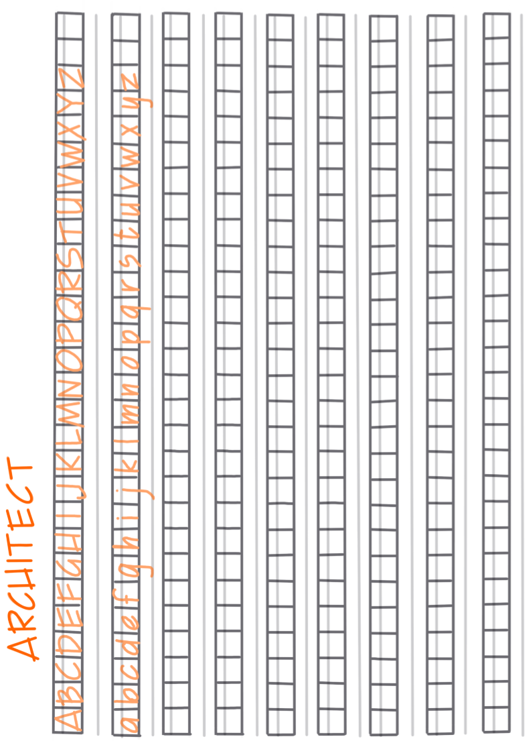

# Practice sheet “Architects Handwriting” Page 2

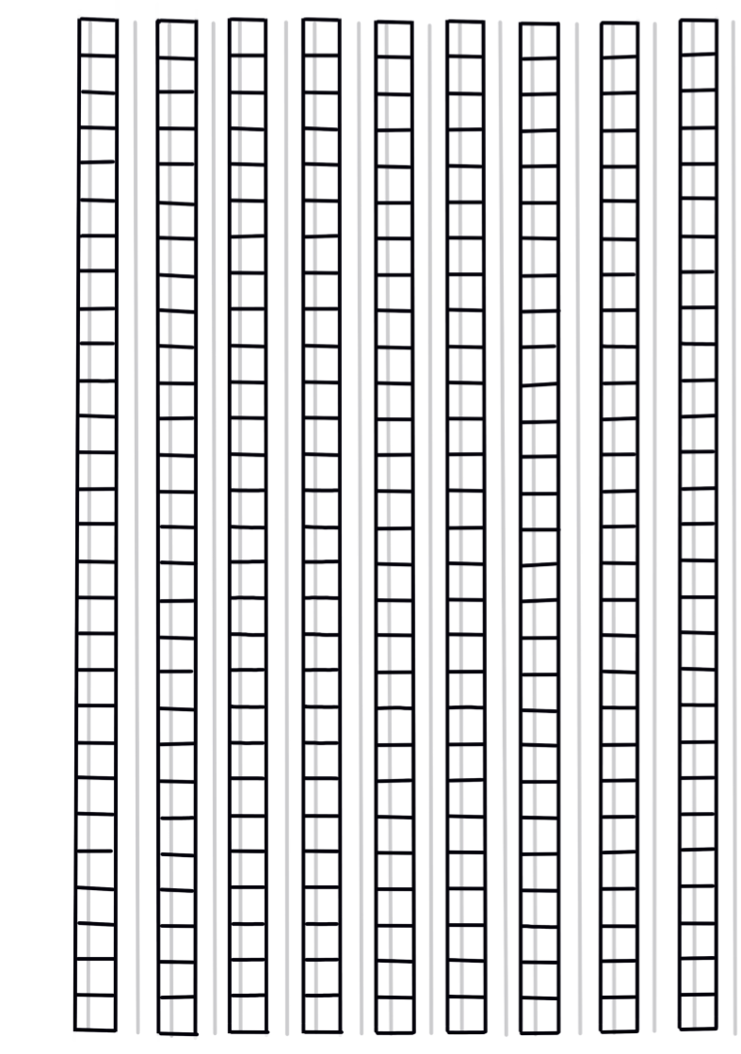

# Practice sheet “Circles”



# Reflection grid

